Submitted by

**[Name Student1**

**Name Student2**

**Name Student3**

**Name Student4**

**…]**

Submitted at



Supervisors

[change accordingly]

**Univ.-Prof. Dr. Stefan Koch**

**Univ.-Prof Dr. Barbara Krumay**

**Dr. René Riedl**

**Dr. David Rückel**

Partner

**[Name Partner]**

Month Year

*(For Information: Month and year of submission to Examination and Recognition Services; Information about the partner is only required, if a partner is involved)*

*(This template is valid since 1.1.2021)*



Master/Bachelor Thesis | Seminar Paper | Project Report

to obtain the academic degree of

Master/Bachelor of Science (MSc/BSc)

in the Master’s Program | in the Bachelor’s Program

Business Informatics

*[For your Information: change accordingly – the second part “to obtain the academic degree of ...” is only for Bachelor and Master Theses]*

[TITLE Of the Thesis]

**[Subtitle of the thesis]**

STATUTORY DECLARATION

I hereby declare that the thesis submitted is my own unaided work, that I have not used other than the sources indicated, and that all direct and indirect sources are acknowledged as references.

This printed thesis is identical with the electronic version submitted.

Place, Date

Signature

*(For Information: The statutory declaration is only necessary for a Master or Bachelor Thesis)*

Table of contents

1. Headline 3

1.1. Headline 3

1.2. Headline 3

1.2.1. Headline 3

1.2.2. Headline 3

**Note regarding bullet lists**

If you would like to add a bullet list, please use the template “List JKU“. Search: Start – paragraph – multilevel list – list styles – list JKU.

* Level 1
  + Level 2
    - Level 3
      * Level 4
        + Level 5

**Note regarding numbered headings as titles**

If you would like to create a list containing numbered headings, please use the template “headlines JKU”. Search: Start – paragraph – multi-level list – list styles – headlines JKU.

# Headline

## Headline

## Headline

### Headline

### Headline

#### Headline

#### Headline

**Note regarding footer**

Date: The current date will automatically appear once the document is open.

Author: Go to File – Options to create your name options.

**Note regarding tables**

Table JKU

|  |  |  |  |
| --- | --- | --- | --- |
|  |  |  |  |
|  |  |  |  |
|  |  |  |  |
|  |  |  |  |
|  |  |  |  |

Table 1: JKU

**Note regarding figures / images**

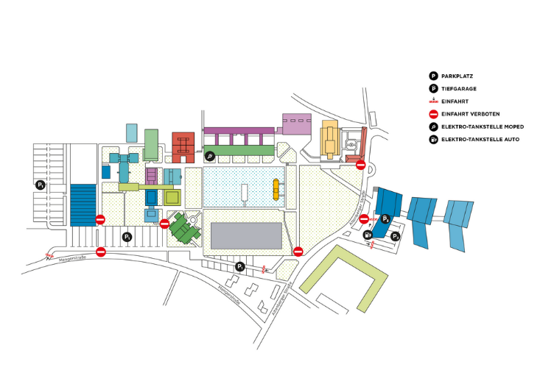

Figure 1: JKU Campus (JKU, 2020)

Tables and figures require consecutive numbers and titles. All tables and figures taken from another source have to be cited accordingly.

**Note regarding the structure of the thesis**

**Kurzzusammenfassung / Abstract (D/E)**

Short summary of your work, 250 – 300 words (approximately), both – abstract in German and English – are required

# Introduction

Description of the topic, like a funnel from the general to the specific.

Problem definition and validation: why is the topic interesting, why is this specific problem worth investigating, where is the research gap?

Research aim and research question (fit)

Short overview, describing the thesis/report.

# State of the Field / Literature / Background Information

Current state of the field in the according academic literature

Goal of this section: show the current state of the field as a basis for the reader’s understanding.

Sub sections are based on content (topics)

# Methodology

Description of the chosen research approach and the methods applied (based on literature). Which research design has been chosen? Which methodologies have been chosen to fulfill the research goals / answer the research question and how are they appropriate for this problem?

## Research Process

Description and documentation on how the methods have been applied (e.g., when, where, how has data been collection, from whom and in which format)

Possible sub sections include a process model and/or phases of the research process

# Results

Description of the results incl. analysis, e.g.

* Data collected in a survey (descriptive and further analysis)
* Description of interview results (summary, what is specific per interview, comparing interviews, categorization – depending on the method selected)
* Literature reviews: description of the selected publications, analysis

# Discussion

Describing, how the research goal was achieved and/or how the research question was answered. Critical discussion of the results, interpretation, comparison with existing knowledge from the literature (as described in section 2), discussion of new knowledge gained from the results, what is interesting / new / unexpected? What is the contribution of your work?

# Conclusion, Limitations and Further Research

Providing a short summary or conclusion, describing limitations (what was not part of this work) and addressing possible future research topics.

# References

Reference style is APA 7, use appropriate tools (Zotero, EndNote, Mendeley)

# List of Tables (Required if document has tables)

# List of Figures (Required if document has figures)

# Appendices (Required if document has appendices)