Curriculum Vitae

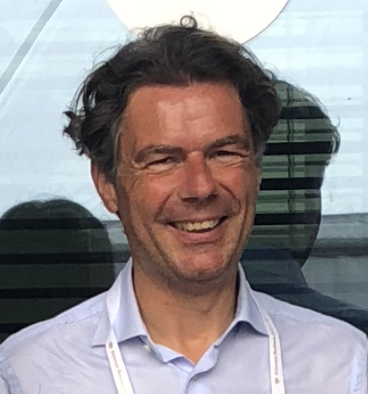
Univ.Prof. MMag. Dr. Wolfgang H. Güttel

Johannes Kepler-University Linz
Institute of Leadership & Change Management

Güttel Management Consulting, Research, & Training
Grinzinger Strasse 115/7
A-1190 Vienna (Austria)

wolfgang.guettel@jku.at
+43.664.5261679 (mobile)

Wolfgang H. Güttel became Full Professor and Head of the Institute of Leadership & Change Management at the Johannes Kepler University (JKU) Linz (Austria) in 2009. Additionally, since 2019 he has been the (founding) Dean of the JKU Business School. His main field of research concerns leadership, strategic change and learning in the context of newly emerging technologies in complex and dynamically evolving environments. His work has been published in various academic books and journals such as Human Relations, Academy of Management Learning & Education, Management Learning, International Journal of Management Research, Harvard Business Review, Schmalenbach Business Review, International Journal of Human Resource Management, Journal of Business Research or Austrian Management Review. He is also engaged in executive education and consulting to advise leaders, firms, and public organizations on managing strategic change. His executive teaching focuses on leadership, team development, organization, strategy, and change management. His academic career includes roles as Dean and Managing Director of the JKU Management School LIMAK (Linz International Management Academy) between 2011 and 2015, Professor at the Universities of Kassel and Hamburg (Germany), Research Fellow at the Universities of Liverpool (United Kingdom) and Padua (Italy) and Assistant Professor at the WU Vienna (Austria). Before embarking upon his academic career, he acted as Management Consultant at Daimler-Benz AG in Stuttgart (Germany), at Diebold Management Consulting in Vienna (Austria) and founded his own consultancy Güttel Management Consulting, Training, & Research in Vienna (Austria).

March 1st, 2020
Table of Contents

Personal Information 3
Education 3
Academic Appointments 4
Business Experience 4
Research 5
Teaching 32
Management Positions & University Self-governance Services 35
Transfer & Third Mission: Management Development & Consulting 36

Personal Information

Date of Birth: June 17th, 1968 in Vienna (Austria); Citizenship: Austrian
Marital Status: Married to Christine Güttel
Children: Kerstin (2006), Annika (2008), Karoline (2011) & Niklas (2011)

Education

WU Vienna - Vienna University of Economics & Business Administration (Austria)
Habilitation (2008): Venia Docendi in Business Administration

WU Vienna - Vienna University of Economics & Business Administration (Austria)
Doctorate (2002): Social & Economics Sciences; passed with distinction (summa cum laude)

Consulting and Training Group (currently offered by Beratergruppe Neuwaldegg; Austria)
Certified Systemic Coach (2001)

University of Vienna (Austria)
Diploma (1997): Political Science: passed with distinction (summa cum laude)

WU Vienna - Vienna University of Economics & Business Administration (Austria)
Diploma (1995): Social and Economics Sciences

Academic Appointments

Johannes Kepler University Linz (Austria)
- Dean of the Business School (since 2019)
- Full Professor & Head of the Institute of Leadership & Change Management (since 2009)

LIMAK Austrian Business School/Johannes Kepler University Linz (Austria)
- Academic Director of the Global Executive MBA (since 2012)
- Academic Director for the Leadership courses (since 2012)
- Academic Director of the Digital Transformation & Change Management MBA (since 2012)
- Dean & Managing Director (2011 - 2015)
´
Austrian Academy of Management & Leadership (Austria)
- Chairman (since 2017)

University of Geneva (Switzerland)
- Visiting Scholar (part-time) (2016/17)

Ruhr University Bochum (Germany)
- Visiting Scholar (part-time) (2016)

University of Kassel (Germany)
- Full Professor & Chair of Human Resource and Change Management (W3) (2009)
- Dean of the Kassel International Management School (KIMS) (2009)
- Full Professor (interim) Chair of Organization &Human Resource Management (W3) (2007-2008)

Hamburg University (Germany)
- Full Professor (interim) & Chair of Organization and Strategic Management (W3) (2008-2009)

University of Padua (Italy)
- Research Fellow at the Institute of Management and Engineering (Full & Part Time) (2007-2009)

University of Liverpool (United Kingdom)
- Research Fellow (Part Time) at the Management School (2007)
- Fellow (Part Time) of the Advanced Institute of Management Research (AIM) (2007)

WU Vienna (Austria)
- Assistant Professor at the Department of Management/Institute of Human Resource Management (2002-2006)

University of Applied Science Wiener Neustadt (Austria)
- Assistant Professor (Part Time) at the Institute of Management Consulting Research (1999-2002)

Business Experience

Güttel Management Consulting, Research, & Training (Vienna; Austria)
- Founder & Managing Partner (since 1999)

LIMAK Austrian Business School/Johannes Kepler University Linz (Austria)
- Managing Director (2011 - 2015)

Diebold Consulting - DaimlerChrysler (Vienna; Austria)
- Consultant (1998 - 1999)

Daimler-Benz (Stuttgart; Germany)
- Consultant (1997 - 1998)

Research

My research interest is shaped by the interplay between stability and change. Uncertainty, complexity, and ambiguity characterize the current state in many markets and economies. In other words, firms and leaders need to facilitate change or to achieve stability in disruptively changing environments. Studying the development path of organizations with their embedded organizational routines and rule systems - sometimes over decades - sheds light on the dynamics between exploiting existing capabilities and facilitating exploration in order to create new capabilities. Over the course of the organization’s development, firms always need to find an appropriate balance between the contradicting demands of short-term efficiency and innovativeness, which is labelled as ambidexterity. HRM and leadership substantially contribute to finding the balance between exploration and exploitation. Thus, in my research I focus on the dynamic interplay between strategy, organization, HRM, and leadership. However, hitherto, our understanding of the role of rule regimes of organizations (formal rules, social norms, and social conventions that constitute organizational routines) and the decision-making heuristics of leaders governing organizational development processes in unpredictable markets is limited. We use The Behavioral Theory of the Firm as the theoretical foundation. Most of our studies are based on case study research using a longitudinal process perspective aiming at theory development. To address existing research gaps, I founded at the Institute of Leadership & Change Management five Competence Centers to bundle our research activities: (1) Microfoundations of Rules & Routines (basic research), (2) Developing Capabilities (applied research), (3) Managing Change (applied research), (4) Dealing with Complexity (applied research), and (5) Leadership, Team, & Organizational Development (theory-practice-transfer; third mission)

Research Centers & Topics

Center for Microfoundations of Rules & Routines (Basic Research)
Mission: We investigate the foundations of capabilities and the interconnectedness between individual cognitions and organizational capabilities (Head: Johanna Grünauer).
Current research projects: The core research project is dedicated to heuristics and simple rules. We use data from case studies and from individual interviews with leaders in order to understand the nexus between individual decision-making and organizational capability refinement and development.

Key papers:
Gruenauer, Johanna/Kratochvil, Renate/Güttel, Wolfgang H. (2019): Requisite Simplicity of Strategic Learning: Applying a Heuristics Process Method. Annual Meeting of the Academy of Management (AoM) 2019, Boston (MA, United States), August 9-13, 2019.
Grünauer, Johanna/Güttel, Wolfgang H./Wurmbrand, Alfred (2018): Simple Rules – Wie sich Unternehmen das Leben einfacher machen können & dennoch effektiver agieren! Zeitschrift für Führung & Organisation, Vol. 87 (2), 112-120.

Center for Developing Capabilities (Applied Research)
Mission: We shed light on the firm’s strategies to create novel capabilities while exploiting their existing core capabilities, often in an ambidextrous setting (Head: Stefan Konlechner).
Current research projects: The main research project focuses on digital transformation and is funded by the Jubiläumsfonds der OeNB. We accompany our project partners KTM, Würth, Silhouette, Palfinger, and Rosenbauer in their activities to modify processes, products, and business models in order to keep pace with their competitors in the age of digital transformation. In particular, we seek to uncover the interplay between exploration and exploitation in the context of capability development. Previous research projects investigated capability development process in various firms such as Fischer Ski & FACC, where analogies led to path-breaking events for creating novel capabilities.

Key papers:
Gusenleitner, Nina/Güttel, Wolfgang H./Konlechner, Stefan W./Gruenauer, Johanna (2020): Tracing the Cognitive Microfoundations of Capability Development Trajectories: The Role of Perceived Identity and Openness to Technological Opportunities. 36th EGOS (European Group of Organization Studies) Colloquium, Hamburg (Germany), July, 2-4, 2020.
Hansen, Nina K./Güttel, Wolfgang H./Swart, Juani (2019): HR in dynamic environments: Exploitative, exploratory and ambidextrous HR architectures. International Journal of Human Resource Management, Vol. 30(4), 648-679. (IF 3,1).

Center for Managing Change (Applied Research)
Mission: We examine the dynamics of change processes in the context of the organization’s path development (Head: Arne Keller).
Current research projects: We currently analyze three avenues for better understanding the dynamics of organizational change and path development. In one research project, we investigated the cultural change in the implementation and modification of safety rules at Boehringer-Ingelheim in order to understand the impact of the change of formal rules and the launch of rule-based initiatives on the corporate culture and vice versa. In another research project – in hospitals – we seek to better understand the dynamics of change by uncovering the relationship between expectations and subsequent experiences. The third research stream perceives changes as continuous events which characterize the firm’s development path. There, we need to better understand path dependency as well as path extension and path breaking on an organizational level.

Key papers:
Güttel, Wolfgang H./Konlechner, Stefan W./Latzke, Markus/Paparella, Caroline (2019): Performing in a Straightjacket: How Organizations Deal Effectively with Publicly Demanded Safety Rules Tightening. 35th EGOS (European Group of Organization Studies) Colloquium, Edinburgh (United Kingdom), July, 4-6, 2019.
Konlechner, Stefan W./Latzke, Markus/Güttel, Wolfgang H./Höfferer, Elisabeth (2019): Prospective Sensemaking during Planned Change Interventions: A Comparison of Two Hospital Units. Human Relations, Vol. 72(4), 706-732. (FT 50; IF 3,0)

Center for Dealing with Complexity (Applied Research)
Mission: We study leader strategies in dealing with complexity when they have to meet contradicting goals or in situations of severe crises (Head: Barbara Müller).
Current research projects: Our studies reveal the role of leaders in difficult situations such as change projects or in ambidextrous settings, where contradicting demands influence their cognition and decision-making. In change processes, leaders play a key role in connecting the firm’s strategy and initiatives with individuals. We use case study-based data from firms, but also from healthcare organizations in order to understand how leaders set priorities, focus attention, or organize communication processes. We also take data from executive education for tracing the creation of different types of leadership identities. Based on the leader’s identity construction, we study the impact on their behavior in demanding situations.

Key papers:
Müller, Barbara/Musil, Katharina/Güttel, Wolfgang H. (2020): Middle Managers' Identity Work in the Phase of Organizational Transition. 36th EGOS (European Group of Organization Studies) Colloquium, Hamburg (Germany), July, 2-4, 2020.
Müller, Barbara/Konlechner, Stefan W./Güttel, Wolfgang H./Link, Karin (2019): The Emperor's New Clothes: How Dealing with Failure Prevents Cultural Change. Organizational Dynamics, Vol. 48(4), . (IF 1,4)

Center for Leadership, Team, & Organizational Development (Theory-Practice-Transfer; Third Mission)
Mission: We transfer our knowledge into practice in executive teaching settings, during team development activities, and in applied research projects with organizations focusing on organizational development and strategic change (Head: Güttel).
Current activities: In the field of theory-practice-transfer, we seek to connect our research to practitioners and to learn from those issues where they struggle with their decision-making due to missing – or at least unknown to them – research results.

Key book & papers:
Güttel, Wolfgang H. (Ed.) (2019): Erfolgreich in turbulenten Zeiten! Impulse für Leadership, Change Management & Ambidexterity. München, Augsburg (2nd Edition).
Güttel, Wolfgang H./Müller, Barbara/Konlechner, Stefan W./Gruenauer, Johanna/Musil, Katharina/Prandstötter, Verena (2019): Scientific Consulting und Scientific Investigation: Analysen, Interpretationen und Perspektiven. Austrian Management Review, Vol. 9, 11-26.
Hasenzagl, Rupert/Güttel, Wolfgang H. (2018): Wozu Beratung? Austrian Management Review, Vol. 8, 11-24.

Publication List

Books & Monographies
- Güttel, Wolfgang H. (Ed.) (2019): Erfolgreich in turbulenten Zeiten! Impulse für Leadership, Change Management & Ambidexterity. München, Augsburg (2nd Edition).
- Güttel, Wolfgang H. (Ed.) (2017): Erfolgreich in turbulenten Zeiten! Impulse für Leadership, Change Management & Ambidexterity. München, Augsburg.
- Güttel, Wolfgang H. (2003): Die Identifikation strategischer immaterieller Vermögenswerte im Post-Merger-Integrationsprozess: Ressourcen- und Wissensmanagement bei Mergers-and-Acquisitions. München, Mering.

Peer-Reviewed Publications
- Güttel, Wolfgang H./Loock, Moritz/Rauch, Madeleine (2020): Heuristics, Rules, & Capabilities: Introduction to the Special Issue. Technological Forecasting & Social Change (forthcoming; IF 3,8)
- Schweiger, Sylvia/Konlechner, Stefan W./Güttel, Wolfgang H. (2019): A Circle of Reinforcing Disidentification: Projects as Means of Promoting Identity Stability and Hindering the Development of a Common Project Group Identity. Project Management Journal, Vol. 51(1), 62-76. (IF 2,0)
- Hansen, Nina K./Güttel, Wolfgang H./Swart, Juani (2019): HR in Dynamic Environments: Exploitative, Exploratory and Ambidextrous HR Architectures. International Journal of Human Resource Management, Vol. 30(4), 648-679. (IF 3,1).
- Müller, Barbara/Konlechner, Stefan W./Güttel, Wolfgang H./Link, Karin (2019): The Emperor's new clothes: How dealing with failure prevents cultural change. Organizational Dynamics, Vol. 48(4). (IF 1,4)
- Konlechner, Stefan W./Latzke, Markus/Güttel, Wolfgang H./Höfferer, Elisabeth (2019): Prospective Sensemaking during Planned Change Interventions: A Comparison of Two Hospital Units. Human Relations, Vol. 72(4), 706-732. (FT 50; IF 3,0)
- Konlechner, Stefan/Müller, Barbara/Güttel, Wolfgang H. (2018): A Dynamic Capabilities Perspective on Managing Technology: A Review, Framework, and Research Agenda. International Journal of Technology Management, Vol. 76 (3-4), 188-213. (IF 1,2)
- Grünauer, Johanna/Güttel, Wolfgang H./Wurmbrand, Alfred (2018): Simple Rules – Wie sich Unternehmen das Leben einfacher machen können und dennoch effektiver agieren! Zeitschrift für Führung & Organisation, Vol. 87 (2), 112-120.
- Frank, Hermann/Güttel, Wolfgang H./Kessler, Alexander (2017): Environmental Dynamism, Hostility, and Dynamic Capabilities in Medium-sized Enterprises. International Journal of Entrepreneurship & Innovation 2017, Vol. 18(3), 185–194.
- Garaus, Christian/Furtmüller, Gerhard/Güttel, Wolfgang H. (2016): Even Tiny Rewards Can Motivate People to Go the Extra Mile: A Study of Truly Piddling Rewards in Online Learning. Harvard Business Review/HBR.org. (FT 50; IF 1,0)
- Konlechner, Stefan W./Güttel, Wolfgang H./Müller, Barbara/Koprax, Irina/Link, Karin (2016): Sheep in Wolf’s Clothing: The Role of Artifacts in Interpretive Schema Change. Schmalenbach Business Review, Vol. 17, 129-150. (IF 0,5)
- Garaus, Christian/Furtmüller, Gerhard/Güttel, Wolfgang H. (2016): The Hidden Power of Small Rewards: The Effects of Insufficient External Rewards on Autonomous Motivation to Learn. Academy of Management Learning & Education, Vol. 15, 45-59. (IF 3,3)
- Garaus, Christian/Güttel, Wolfgang H./Konlechner, Stefan W./Koprax, Irina/ Lackner, Hubert/Link, Karin/Müller, Barbara (2016): Bridging knowledge in ambidextrous HRM systems: Empirical evidence from Hidden Champions. International Journal of Human Resource Management, Vol. 27: 355-381. (IF 3,1)
- Güttel, Wolfgang H./Konlechner, Stefan W./Trede, Julia K. (2015): Standardized Individuality versus Individualized Standardization: The Role of the Context in Structurally Ambidextrous Organizations. Review of Managerial Science, Vol. 9, 261-284. (IF 2,0)
- Trede, Julia K./Güttel, Wolfgang H. (2014): Geprägte Entwicklung von Organisationen: Fundamentales Imprinting und dynamische Weiterentwicklung. Zeitschrift für betriebswirtschaftliche Forschung, Vol. 66 (Sonderband: Zukunftsfähige Unternehmensführung zwischen Stabilität und Wandel), 18-40. (IF 0,5)
- Müller-Seitz, Gordon/Güttel, Wolfgang H. (2014): Towards a Choreography of Congregating – A Practice-based Perspective on Organizational Absorptive Capacity in a Semiconductor Industry Consortium. Management Learning, Vol. 45, 477-497. (IF 1,4)
- Wilhelm, Stefan/Güldenberg, Stefan/Güttel, Wolfgang H. (2013): Do You Know Your Valuable Customers? Journal of Knowledge Management , Vol. 17, 661-676. (IF 2,1)
- Vogel, Rick/Güttel, Wolfgang H. (2013): The Dynamic Capability View in Strategic Management: A Bibliometric Review. International Journal of Management Review, Vol. 15, 426-446. (IF 7,6)
- Antonacopoulou, Elena/Güttel, Wolfgang H./ Kaiser, Stephan/Macpherson, Allan/ Méric, Jérôme/Müller-Seitz, Gordon (2012): Why Strategic Organisational Learning and Why Now? International Journal of Knowledge Management Studies, Vol. 5, 1-9.
- Güttel, Wolfgang H./Konlechner, Stefan W./Müller, Barbara (2012): Entscheidungsmuster und Veränderungsarchitekturen in Wandelprozessen: Eine Dynamic Capabilities-Perspektive. Zeitschrift für betriebswirtschaftliche Forschung, Vol. 64, 630-654. (IF 0,5)
- Filippini, Roberto/Güttel, Wolfgang H./Nerotti, Paolo/Nosella, Anna (2012): The Different Modes for Absorbing Knowledge: An Analytic Lens on Absorptive Capacity from a Process Perspective. International Journal of Knowledge Management Studies, Vol. 5, 45-65.
- Güttel, Wolfgang H./Konlechner, Stefan W./Müller, Barbara/Trede, Julia K./Lehrer, Mark (2012): Faciliating Ambidexterity in Replicator Organizations: Artifacts in their Role as Routine-Re-Creators. Schmalenbach Business Review, Vol. 64, 187-203. (IF 0,5)
- Filippini, Roberto/Güttel, Wolfgang H./Nosella, Anna (2012): Ambidexterity and the Evolution of KM Initiatives. Journal of Business Research, Vol. 65, 3, 317-324. (IF 4.0)
- Filippini, Roberto/Güttel, Wolfgang H./Nosella, Anna (2012): Dynamic Capabilities and the Evolution of Knowledge Management Practices in SMEs. International Journal of Technology Management, Vol. 60, 202-220. (IF 1,2)
- Konlechner, Stefan W./Güttel, Wolfgang H. (2011): Die Replikation organisationaler Routinen: Replikationsstrategien zwischen Templates und Prinzipien. Jahrbuch Strategisches Kompetenz-Management, Vol. 5, 1-27.
- Frank, Hermann/Güttel, Wolfgang H./Weismeier-Sammer, Daniela (2010): Ambidexterity in Familienunternehmen: Die Top-Management-Familie als Innovationsinkubator. Managementforschung, Vol. 20, 117-156.
- Konlechner, Stefan W./Güttel, Wolfgang H. (2010): Die Evolution von Replikationsstrategien. Jahrbuch Strategisches Kompetenz-Management: Ambidexterity, Vol. 4, 27-56.
- Filippini, Roberto/Güttel, Wolfgang H./Nosella, Anna (2010): Extracting Knowledge from Collaborations: The Role of Absorptive Capacity in SMEs. Advances in Applied Business Strategy, Vol. 12, 63-86.
- Antonacopoulou, Elena P./Güttel, Wolfgang H. (2010): Staff Induction Practices and Organizational Socialization: A Review and Extension of the Debate. Society and Business Review, Vol. 5, 1/10, 22-47. (IF 0,9)
- Güttel, Wolfgang H./Konlechner, Stefan W. (2009): Continuously Hanging by a Thread: Managing Contextually Ambidextrous Organizations. Schmalenbach Business Review, Vol. 71, 2/09, 150-172. (IF 0,5)
- Güttel. Wolfgang H./Konlechner, Stefan W./Kohlbacher, Florian/Haltmeyer, Beate (2009): Strategies against Competence Obsolescence: The Case of Research-Intensive Organizations. International Journal of Human Resource Development and Management, Vol. 9, 2,3/09, 124-148.
- Konlechner, Stefan W./Güttel, Wolfgang H. (2009): Kontinuierlicher Wandel mit Ambidexterity. Zeitschrift für Führung und Organisation, Vol. 78, 01/09, 44–52.
- De Toni, Alberto/Filippini, Roberto/Güttel, Wolfgang H./Migliarese, Piero/Nosella, Anna/Vinelli, Andrea (2008): I progetti di gestione della conoscenza e lo sviluppo delle competenze dinamiche. Finanza Marketing e Produzione, 4/08, 120-138.
- Brandl, Julia/Güttel, Wolfgang H. (2007): Organizational Antecedents of Pay-for-Performance Systems in Nonprofit Organizations. Voluntas International Journal of Voluntary and Nonprofit Organizations, 2/07, Vol. 18, 176-199. (IF 1,8)
- Güttel, Wolfgang H. (2007): Wissenstransfer in Organisationen: Koordinationsmechanismen und Anreizsysteme als Gestaltungsparameter. Zeitschrift für betriebswirtschaftliche Forschung, 6/07, Vol. 59, 465-486. (IF 0,5)
- Güttel, Wolfgang H. (2007): Corporate Entrepreneurship (CE) und Strategisches Kompetenz-Management. Jahrbuch Strategisches Kompetenz-Management, Vol. 1, 175-201.
- Brandl, Julia/Güttel, Wolfgang H./Konlechner, Stefan W./Eckardstein, Dudo von/Beisheim, Magret/Elsik, Wolfgang (2007): Pay-for-Performance in Nonprofit-Organisationen: Eine Replik auf den Praktikerbeitrag von Ulrich Drost. Zeitschrift für Personalforschung, 2/07, Vol. 21, 258-260. (IF 1,3)
- Brandl, Julia/Güttel, Wolfgang H./Konlechner, Stefan W./Beisheim, Magret/Elsik, Wolfgang/Eckardstein, Dudo von (2006): Entwicklungsdynamik von Vergütungssystemen in NPOs. Zeitschrift für Personalforschung, 4/06, Vol. 20, 356-374. (IF 1,3)
- Dietrich, Angelika/Frank, Hermann/Güttel, Wolfgang H./Hasenzagl, Rupert (2005): Das Feuer kleiner Gruppen: Analyse der Entwicklungslogik und -dynamik eines Beratungsprozesses. Gruppendynamik und Organisationsentwicklung, 3/05, Vol. 36, 271-284.
- Campbell, David F.J./Güttel, Wolfgang H. (2005): Knowledge Production in Firms: Research Networks and the “Scientification” of Business R&D. International Journal of Technology Management, 1,2/05, Vol. 31, 152-175. (IF 1,2)
- Güttel, Wolfgang H. (2003): Die Identifikation strategischer immaterieller Vermögenswerte im Post-Merger-Integrationsprozess: Ressourcen- und Wissensmanagement bei Mergers-and-Acquisitions. Zeitschrift für Personalforschung (Dissertationsheft 2003), 4/03, Vol. 17, 399-401. (IF 1,3)
- Güttel, Wolfgang H. / Dietrich, Angelika (2001): Aspekte der externen Informationsbeschaffung im Rahmen des Wissensmanagement in kleinen und mittleren Beratungsunternehmen. Wirtschaftsinformatik/Business & Information Systems Engineering, 5/01, Vol. 43, 477-486. (IF 3,4)
- Güttel, Wolfgang H. (1998): Programmatische Innovationen und Parteienwettbewerb. Eine empirische Analyse der Wahlprogramme der österreichischen Parteien von 1983 bis 1995. Österreichische Zeitschrift für Politikwissenschaft, 2/98, Vol. 27, 193-210.

Theory-Practice-Transfer Publications
- Gersch, Martin/Güldenberg, Stefan/Güttel, Wolfgang H./Müller-Seitz, Gordon/Renzl, Birgit/Schulz, Ann-Christine (2020): Gestaltungsherausforderungen der digitalen Transformation: Pfade erkennen, gestalten oder verlassen. Wirtschaftswissenschaftliches Studium (WiSt) (accepted for publication; forthcoming).
- Güttel, Wolfgang H./Müller, Barbara/Konlechner, Stefan W./Gruenauer, Johanna/Musil, Katharina/Prandstötter, Verena (2019): Scientific Consulting und Scientific Investigation: Analysen, Interpretationen und Perspektiven. Austrian Management Review, Vol. 9, 11-26.
- Güttel, Wolfgang H./Güttel, Christine/Voglmayr, Rene (2019): Management Development: Fähigkeiten, Wandel und Leistungspotenzial. Austrian Management Review , Vol. 9, 68-77.
- Hasenzagl, Rupert/Güttel, Wolfgang H. (2018): Wozu Beratung? Austrian Management Review, Vol. 8, 11-24.
- Güttel, Wolfgang H. (2018): Hoffentlich tritt der Chef bald ab! Changemanagement, 6/18, 20-23.
- Güttel, Wolfgang H. (2017): Performance Core: Führung und Wandel des Leistungskerns. Austrian Management Review, Vol. 7, 9-31.
- Güttel, Wolfgang H./Gschwandtner, Johannes/Gschwandtner, Andreas (2016): Die inkrementelle Revolution: Industrie 4.0 bei technosert electronic. Austrian Management Review, Vol. 6, 84-97.
- Güttel, Wolfgang H./Koprax, Irina (2015): FACC Produktentstehungsprozess: Analyse & Optimierung. Take-off, 2/15, 10-11.
- Güttel, Wolfgang H. (2015): Was wir wollen sollen: Anspruchsniveaus, Entscheidungsheuristiken & Regelregime. Austrian Management Review, Vol. 5, 12-24.
- Güttel, Wolfgang H./Wiesinger, Judith (2015): Leadership in turbulenten Zeiten: Resilienz und Entscheidungsheuristiken bei disruptiven Veränderungen. Austrian Management Review, Vol. 5, 33-45.
- Koprax, Irina/Garaus, Christian/Güttel, Wolfang H. (2015): Dieser Weg wird kein leichter sein: Wie dem eingeschlagenen Pfad der Unternehmensentwicklung eine neue Richtung gegeben werden kann. Austrian Management Review, Vol. 5, 60-68.
- Güttel, Wolfgang H./Link, Karin (2014): Führung in Veränderungsprozessen: Sinn, Motivation und Selbststeuerung. Austrian Management Review, Vol. 4, 19-29.
- Güttel, Wolfgang H./Leitner, Gerhard (2014): Die LIMAK feiert ihr 25jähriges Bestehen. Austrian Management Review, Vol. 4, 64-65.
- Güttel, Wolfgang H. (2013): Konzeptionelle Kompetenz: Leadership aus der Perspektive der New Austrian School of Management. Austrian Management Review, Vol. 3, 80-90.
- Klinger, Stephan/Güttel, Wolfgang H. (2013): Paradoxien des Wandels rund um die Abschaffung der Stempelmarke: Zur Bedeutung von Legitimitätsliquidität in Veränderungsprozessen Austrian Management Review, Vol. 3, 20-27.
- Garaus, Christian/Güttel, Wolfgang H. (2013): Erfolgreiches Management von radikalen und inkrementellen Innovationen: Erkenntnisse aus Österreichs mittelständischen und großen High-Tech-Unternehmen. Austrian Management Review, Vol. 3, 52-59.
- Güttel, Wolfgang H./Pichler, Otmar (2012): Führen in schwierigen Situationen. Personal Manager, 5/12, 12-16.
- Güttel, Wolfgang H./Müller, Barbara (2012): Schnelle Entscheidungen in turbulenten Zeiten: Wie Selbststeuerungsmechanismen die Veränderungsfähigkeit fördern. HR-Times, 2/12, 9.
- Güttel, Wolfgang H./Leitner, Gerhard (2012): Strategischer Wandel: Die New Austrian School of Management in der Praxis. Austrian Management Review, Vol. 2, 13-23.
- Güttel, Wolfgang H. (2011): New Austrian School of Management. Austrian Management Review, Vol. 1, 17-29.
- Güttel, Wolfgang H./Wize, Christoph (2011): Evolutionäres IT-basiertes Wissensmanagement. Austrian Management Review, Vol. 1, 70-80.
- Güttel, Wolfgang H./Eckardstein, Dudo von (2005): Grundlagen und Wirkungsbereiche qualitätsvoller Beratung. Corporate Consulting News, 1/05, 11.
- Güttel, Wolfgang H. (2003): Wissen teilen braucht Vertrauen. HiTech, 1/03, 18-20.
- Dietrich, Angelika/ Güttel, Wolfgang H. (2001): Empirische Analyse zur Verbreitung sowie zur Erstellung und Einführung der Balanced Scorecard in österreichischen Großunternehmen. Teil 2: Erstellung und Einführung. Controller News 5/01, 130-133.
- Dietrich, Angelika/ Güttel, Wolfgang H. (2001): Die Balanced Scorecard in österreichischen Großunternehmen. Teil 1: Empirische Analyse zur Verbreitung. Controller News 4/01, 98-101.
- Dietrich, Angelika/ Güttel, Wolfgang H. (2001): Perspektiven der Informationsbeschaffung im Rahmen des Wissensmanagements. Wing Business 2/01, 34-37.
- Güttel, Wolfgang H. (1994): Liberalismus und das Prinzip der Nachhaltigkeit (Sustainable Development). liberal aktuell 2/94, 68-74.

Chapters in Books
- Güttel, Wolfgang H./Güldenberg, Stefan/Klinger, Stephan/ Renzl, Birgit (2019): Austrian School of Management: Wissen, Lernen und Unternehmertum in dynamischen Märkten. Güttel, Wolfgang H. (Ed).: Erfolgreich in turbulenten Zeiten: Impulse für Leadership, Change Management und Ambidexterity. München, Augsburg, 9-26.
- Güttel, Wolfgang H. (2019): Performance Core: Führung, Wandel und Leistung. Güttel, Wolfgang H. (Ed).: Erfolgreich in turbulenten Zeiten: Impulse für Leadership, Change Management und Ambidexterity. München, Augsburg, 27-59.
- Güttel, Wolfgang, H. (2019): Was wir wollen sollen: Anspruchsniveau, Entscheidungsheuristiken und Regelregime. Güttel, Wolfgang H. (Ed).: Erfolgreich in turbulenten Zeiten: Impulse für Leadership, Change Management und Ambidexterity. München, Augsburg, 60-74.
- Gruenauer, Johanna/Güttel, Wolfgang H./Wurmbrand, Alfred (2019): Simple Rules: Regeln, Lernen und Kompetenzentwicklung. Güttel, Wolfgang H. (Ed).: Erfolgreich in turbulenten Zeiten: Impulse für Leadership, Change Management und Ambidexterity. München, Augsburg, 75-87.
- Güttel, Wolfgang H./Müller, Barbara/Konlechner, Stefan W./Gruenauer, Johanna/Musil, Katharina/Prandstötter, Verena (2019): Scientific Consulting und Scientific Investigation: Analysen, Interpretationen und Perspektiven. Güttel, Wolfgang H. (Ed).: Erfolgreich in turbulenten Zeiten: Impulse für Leadership, Change Management und Ambidexterity. München, Augsburg, 88-102.
- Güttel, Wolfgang H./Kratochvil, Renate (2019): Effektive Führung: Führungsidentität, Aufgaben und strategisch-konzeptionelle Fähigkeiten. Güttel, Wolfgang H. (Ed).: Erfolgreich in turbulenten Zeiten: Impulse für Leadership, Change Management und Ambidexterity. München, Augsburg, 103-127.
- Güttel, Wolfgang H./Pichler, Otmar (2019): Führen in schwierigen Situationen: Ursachen, Erklärungen und Lösungsstrategien. Güttel, Wolfgang H. (Ed).: Erfolgreich in turbulenten Zeiten: Impulse für Leadership, Change Management und Ambidexterity. München, Augsburg, 128-137.
- Güttel, Wolfgang H./Wiesinger, Judith (2019): Leadership in turbulenten Zeiten: Resilienz, Entscheidungsheuristiken und disruptive Veränderungen. Güttel, Wolfgang H. (Ed).: Erfolgreich in turbulenten Zeiten: Impulse für Leadership, Change Management und Ambidexterity. München, Augsburg, 138-156.
- Güttel,Wolfgang H./Müller, Barbara (2019): Human Resource Architectures: Strategien, Systeme und Marktdynamiken. Güttel, Wolfgang H. (Ed).: Erfolgreich in turbulenten Zeiten: Impulse für Leadership, Change Management und Ambidexterity. München, Augsburg, 157-169.
- Güttel, Wolfgang H./Güttel, Christine/Voglmayr, René (2019): Management Development: Fähigkeiten, Wandel und Leistungspotenzial. Güttel, Wolfgang H. (Ed).: Erfolgreich in turbulenten Zeiten: Impulse für Leadership, Change Management und Ambidexterity. München, Augsburg, 170-179.
- Güttel, Wolfgang H./Link, Karin (2019): Führung in Veränderungsprozessen: Sinn, Motivation und Selbststeuerung. Güttel, Wolfgang H. (Ed).: Erfolgreich in turbulenten Zeiten: Impulse für Leadership, Change Management und Ambidexterity. München, Augsburg, 180-193.
- Güttel, Wolfgang H., Konlechner, Stefan W./Latzke, Markus/Musil, Katharina (2019): Zuversicht im Wandel: Erwartungen, Erfahrung und Veränderungsdynamik. Güttel, Wolfgang H. (Ed).: Erfolgreich in turbulenten Zeiten: Impulse für Leadership, Change Management und Ambidexterity. München, Augsburg, 194-203.
- Hasenzagl, Rupert/Güttel, Wolfgang H. (2019): Wozu Unternehmensberatung? Grundtypen, Möglichkeiten und Grenzen. Güttel, Wolfgang H. (Ed).: Erfolgreich in turbulenten Zeiten: Impulse für Leadership, Change Management und Ambidexterity. München, Augsburg, 204-217.
- Koprax, Irina/Garaus, Christian/Güttel, Wolfgang H. (2019): Unternehmensentwicklung beeinflussen? Pfadabhängigkeit, Pfadbruch und Pfadkreation. Güttel, Wolfgang H. (Ed).: Erfolgreich in turbulenten Zeiten: Impulse für Leadership, Change Management und Ambidexterity. München, Augsburg, 218-227.
- Güttel, Wolfgang H./Güldenberg, Stefan/Wize, Christoph (2019). Wenn wir alles wüssten was wir wissen! Technik, Menschen und Wissensmanagement. Güttel, Wolfgang H. (Ed).: Erfolgreich in turbulenten Zeiten: Impulse für Leadership, Change Management und Ambidexterity. München, Augsburg, 228-241.
- Güttel, Wolfgang H./Konlechner, Stefan W. (2019): Entwicklungskräfte in Organisationen: Exploration, Exploitation und Ambidexterity. Güttel, Wolfgang H. (Ed).: Erfolgreich in turbulenten Zeiten: Impulse für Leadership, Change Management und Ambidexterity. München, Augsburg, 242-268.
- Konlechner, Stefan/Güttel, Wolfgang H. (2019): Kontinuierlicher Wandel durch Ambidexterity: Formen, Einsatzbedingungen und organisationales Lernen. Güttel, Wolfgang H. (Ed).: Erfolgreich in turbulenten Zeiten: Impulse für Leadership, Change Management und Ambidexterity. München, Augsburg, 269-286.
- Güttel, Wolfgang H./Leitner, Gerhard (2019): Strategische Entwicklungsprozesse: Stabilität, Wandel und Ambidexterity. Güttel, Wolfgang H. (Ed).: Erfolgreich in turbulenten Zeiten: Impulse für Leadership, Change Management und Ambidexterity. München, Augsburg, 287-300.
- Güttel, Wolfgang H./Gschwandtner, Johannes/Gschwandtner, Andreas (2019): Digitalisierung und die inkrementelle Revolution: Strategien, Organisationsformen und Führung. Güttel, Wolfgang H. (Ed).: Erfolgreich in turbulenten Zeiten: Impulse für Leadership, Change Management und Ambidexterity. München, Augsburg, 301-315.
- Güttel, Wolfgang H./Klinger, Stephan (2019): Paradoxien des Wandels: Systemlogiken, Widersprüche und Legitimitätsliquidität. Güttel, Wolfgang H. (Ed).: Erfolgreich in turbulenten Zeiten: Impulse für Leadership, Change Management und Ambidexterity. München, Augsburg, 315-329.
- Güttel, Wolfgang H. (2017): New Austrian School of Management: Wissen, Lernen und Unternehmertum in dynamischen Märkten. Güttel, Wolfgang H. (Ed).: Erfolgreich in turbulenten Zeiten: Impulse für Leadership, Change Management und Ambidexterity. München, Augsburg, 3-18.
- Güttel, Wolfgang H. (2017): Führung und Wandel des Leistungskerns von Organisationen. Güttel, Wolfgang H. (Ed).: Erfolgreich in turbulenten Zeiten: Impulse für Leadership, Change Management und Ambidexterity. München, Augsburg, 19-48.
- Güttel, Wolfgang H. (2017): Was wir wollen sollen: Anspruchsniveau, Entscheidungsheuristiken und Regelregime. Güttel, Wolfgang H. (Ed).: Erfolgreich in turbulenten Zeiten: Impulse für Leadership, Change Management und Ambidexterity. München, Augsburg, 49-64
- Gruenauer, Johanna/Güttel, Wolfgang H./Wurmbrand, Alfred (2017): Simple Rules: Wie sich Unternehmen das Leben einfacher machen können und dennoch effektiver agieren. Güttel, Wolfgang H. (Ed).: Erfolgreich in turbulenten Zeiten: Impulse für Leadership, Change Management und Ambidexterity. München, Augsburg, 65-80.
- Güttel, Wolfgang H. (2017): Effektive Führung: Konzeptionelle Fähigkeiten im Leadership. Güttel, Wolfgang H. (Ed).: Erfolgreich in turbulenten Zeiten: Impulse für Leadership, Change Management und Ambidexterity. München, Augsburg, 83-96.
- Güttel, Wolfgang H./Pichler, Otmar (2017): Führen in schwierigen Situationen: Ursachen und Lösungsstrategien. Güttel, Wolfgang H. (Ed).: Erfolgreich in turbulenten Zeiten: Impulse für Leadership, Change Management und Ambidexterity. München, Augsburg, 97-106.
- Güttel, Wolfgang H./Wiesinger, Judith (2017): Leadership in turbulenten Zeiten: Resilienz und Entscheidungsheuristiken bei disruptiven Veränderungen. Güttel, Wolfgang H. (Ed).: Erfolgreich in turbulenten Zeiten: Impulse für Leadership, Change Management und Ambidexterity. München, Augsburg, 107-126.
- Güttel, Wolfgang H./Müller, Barbara (2017): Komplexes Kontextmanagement – der „neue“ Weg des Personalmanagements?! Güttel, Wolfgang H. (Ed).: Erfolgreich in turbulenten Zeiten: Impulse für Leadership, Change Management und Ambidexterity. München, Augsburg, 127-134.
- Güttel, Wolfgang H./Link, Karin (2017): Führung in Veränderungsprozessen: Sinn, Motivation und Selbststeuerung. Güttel, Wolfgang H. (Ed).: Erfolgreich in turbulenten Zeiten: Impulse für Leadership, Change Management und Ambidexterity. München, Augsburg, 137-150.
- Koprax, Irina/Garaus, Christian/Güttel, Wolfgang H. (2017): Pfadabhängigkeit und Pfadkreation. Güttel, Wolfgang H. (Ed).: Erfolgreich in turbulenten Zeiten: Impulse für Leadership, Change Management und Ambidexterity. München, Augsburg, 151-160.
- Güttel, Wolfgang H./Leitner, Gerhard (2017): Strategischer Wandel: Dimensionen der Neuausrichtung. Güttel, Wolfgang H. (Ed).: Erfolgreich in turbulenten Zeiten: Impulse für Leadership, Change Management und Ambidexterity. München, Augsburg, 161-172.
- Güttel, Wolfgang H./Wize, Christoph (2017): Unternehmens-WIKIs im Wissensmanagement. Güttel, Wolfgang H. (Ed).: Erfolgreich in turbulenten Zeiten: Impulse für Leadership, Change Management und Ambidexterity. München, Augsburg, 173-184.
- Güttel, Wolfgang H./Konlechner, Stefan W. (2017): Ambidextrie als Ansatz zur Balancierung von Effizienz und Innovativität in Organisationen. Güttel, Wolfgang H. (Ed).: Erfolgreich in turbulenten Zeiten: Impulse für Leadership, Change Management und Ambidexterity. München, Augsburg, 187-216.
- Konlechner, Stefan/Güttel, Wolfgang H. (2017): Kontinuierlicher Wandel: Organisationales Lernen bei struktureller und kontextueller Ambidexterity. Güttel, Wolfgang H. (Ed).: Erfolgreich in turbulenten Zeiten: Impulse für Leadership, Change Management und Ambidexterity. München, Augsburg, 217-234.
- Güttel, Wolfgang H./Gschwandtner, Johannes/Gschwandtner, Andreas (2017): Industrie 4.0: Die inkrementelle Revolution. Güttel, Wolfgang H. (Ed).: Erfolgreich in turbulenten Zeiten: Impulse für Leadership, Change Management und Ambidexterity. München, Augsburg, 235-250.
- Güttel, Wolfgang H./Klinger, Stephan (2017): Paradoxien des Wandels: Zur Bedeutung von Legitimitätsliquidität in Veränderungsprozessen. Güttel, Wolfgang H. (Ed).: Erfolgreich in turbulenten Zeiten: Impulse für Leadership, Change Management und Ambidexterity. München, Augsburg, 251-259.
- Güttel, Wolfgang H./Konlechner, Stefan W. (2014): Ambidextrie als Ansatz zur Balancierung von Effizienz und Innovativität in Organisationen. Burr, Wolfgang (Ed.): Innovation: Theorien, Konzepte und Methoden der Innovationsforschung, Stuttgart, 373-403.
- Güttel, Wolfgang H./Koprax, Irina/Garaus, Christian (2014): A Scientific Lens on FACC’s Developent - FACC aus wissenschaftlicher Perspektive. FACC AG (Ed.): Pilot, Passion, Partnership: FACC Bordbuch - FACC Logbook. Ried im Innkreis, 16-25.
- Koprax, Irina/Mayrhofer, Eva/Güttel, Wolfgang H. (2014): HRM as Challenge for the Top Management of Technology Start-ups. Machado, C.F./Davim, J. P. (Eds): Human Resources Management and Technological Challenges. Berlin, New York, 43-68.
- Lackner, Hubert/Güttel, Wolfgang H./Konlechner, Stefan W./Hansen, Nina Katrin/Garaus, Christian/Müller, Barbara (2013): Ambidextrous Learning Architectures and the Role of HRM Systems. Fernandel, Anabel et al. (Eds.): Shedding new lights on organisationla learning, knowledge and capabilities. Cambridge, 333-356.
- Garaus, Christian/Güttel, Wolfgang H./Konlechner, Stefan W./Lackner, Hubert/Müller, Barbara (2013): Ambidexterity. Carayannis, Elias/Campbell, David F.J. (Eds.): Encyclopedia of Creativity, Invention, Innovation, and Entrepreneurship. Berlin, New York, 52-56.
- Campbell, David F.J./Carayannis, Elias/Güttel, Wolfgang H. (2013): Academic Firm. Carayannis, Elias/Campbell, David F.J. (Eds.): Encyclopedia of Creativity, Invention, Innovation, and Entrepreneurship. Berlin, New York, 17-23.
- Güttel, Wolfgang H./Müller, Barbara (2012): Komplexes Kontextmanagement – der „neue“ Weg des Personalmanagements?! Stein, Volker (Ed.): Aufbruch des strategischen Personalmanagements in die Dynamisierung : ein Gedanke für Christian Scholz. Baden-Baden, 15-23.
- Hansen, Nina Katrin/Güttel, Wolfgang H./Antonacopoulou, Elena P. (2010): Induction Practices and the Continuous Recreation of Organizational Memory. In: Stephan, Michael/Freiling, Jörg (Eds.): Strategisches Kompetenz-Management und Ambidexterity. Wiesbaden, 41-56.
- Filippini, Roberto/Güttel, Wolfgang H./Nosella, Anna (2010): Gestire la conoscenza per l’efficienza e l’innovatzione. Filippini, Roberto/Güttel, Wolfgang H./Nosella, Anna (Eds.): Dall’AUT-AUT all’ET-ET: Competere con la conoscenza bilanciando efficienza e innovazione. Milano, 15-19.
- Filippini, Roberto/Güttel, Wolfgang H./Nosella, Anna (2010): Che cosa succede in pratica? Filippini, Roberto/Güttel, Wolfgang H./Nosella, Anna (Eds.): Dall’AUT-AUT all’ET-ET: Competere con la conoscenza bilanciando efficienza e innovazione. Milano, 56-60.
- Filippini, Roberto/Güttel, Wolfgang H./Nosella, Anna (2010): Bilanciare efficienza e innovazione: risultati e raccomandazioni manageriali. Filippini, Roberto/Güttel, Wolfgang H./Nosella, Anna (Eds.): Dall’AUT-AUT all’ET-ET: Competere con la conoscenza bilanciando efficienza e innovazione. Milano, 190-200.
- Güttel, Wolfgang H (2010): L’organizzazione della conoscenza con strumenti wiki in Pixelwings. Filippini, Roberto/Güttel, Wolfgang H./Nosella, Anna (Eds.): Dall’AUT-AUT all’ET-ET: Competere con la conoscenza bilanciando efficienza e innovazione. Milano, 175-179.
- Güttel, Wolfgang H. (2009): Corporate Entrepreneurship und Dynamic Capabilities: Strategien für Innovation und Kompetenzentwicklung In: Frank, Hermann (Ed.): Corporate Entrepreneurship; 2nd Edition, Wien, 125-165.
- Hasenzagl, Rupert/Güttel, Wolfgang H. (2009): Personalmanagement und Führung im Kontext von Corporate Entrepreneurship. In: Frank, Hermann (Ed.): Corporate Entrepreneurship; 2nd Edition, Wien, 225-246.
- Konlechner, Stefan W./Güttel, Wolfgang H. (2008): Kompetenzaktualisierung in forschungsintensiven Organisationen: Zwischen Monodexterity und Ambidexterity. In: Kasper, Helmut/Mühlbacher, Jürgen (Eds.): Wettbewerbsvorteile durch organisationales und individuelles Kompetenzmanagement Wien, 45-64.
- Konlechner, Stefan W./Güttel, Wolfgang H. (2008): Die Einbindung von Lernerfahrung in Replikationsstrategien. In: Eisenkopf, A./Opitz, C./Proff, Heike (Eds.): Strategisches Kompetenz-Management in der Betriebswirtschaftslehre: Eine Standortbestimmung. Wiesbaden, 13-19.
- Güttel, Wolfgang H. (2007): Anschlussfähigkeit, Akzeptanz oder Ablehnung von Interventionen in Beratungsprozessen. In: Nissen, Volker (Ed.): Consulting Research: Unternehmensberatung aus wissenschaftlicher Perspektive. Wiesbaden, 281-294.
- Eckardstein, Dudo von/Güttel, Wolfgang H. (2006): § 13 Abs. 6 Universitätsgesetz 2002: Wissensbilanzierung und/oder Wissenscontrolling an Universitäten? In: Welte, Heike/Auer, Manfred/Meister-Scheytt, Claudia (Eds.): Management von Universitäten. Zwischen Tradition und (Post-) Moderne. 2nd Edition. München, Mering, S. 377-398.
- Güttel, Wolfgang H. (2006): Methoden der Identifikation organisationaler Kompetenzen: Mapping vs. Interpretation. In: Burmann, Christoph/Freiling, Jörg/Hülsmann, Michael (Eds.): Neue Perspektiven des Strategisches Kompetenz-Managements. Wiesbaden, 411-435.
- Güttel, Wolfgang H. (2006): Corporate Entrepreneurship als Strategie. In: Frank, Hermann (Ed.): Corporate Entrepreneurship. Wien, 79-111.
- Hasenzagl, Rupert/Güttel, Wolfgang H. (2006): Personalmanagement und Führung im Kontext von Corporate Entrepreneurship. In: Frank, Hermann (Ed.): Corporate Entrepreneurship. Wien, 151-168.
- Güttel, Wolfgang H. (2006): Knowledge Production: Competence Development and Innovation – Between Invention and Routine. In: Carayannis, Elias/Campbell, David F.J. (Eds.): Knowledge Creation, Diffusion and Use in Innovation Networks & Clusters: A Comparative Systems Approach Across the U.S., Europe and Asia. Westpoint, London, 52-66.
- Güttel, Wolfgang H. (2006): Identifikation organisationaler Kompetenzen bei Mergers-and-Acquisitions. In: Matzler, Kurt, Hinterhuber, Hans H., Renzl, Birgit, Rothenberger, S. (Eds.): Immaterielle Vermögenswerte. Handbuch der intangible Assets. Berlin, 399-419.
- Klinger, Stephan M./Güttel, Wolfgang H. (2005): „Gnothi Seauton – Erkenne dich selbst“ – Die implizite Kommunikation über Recruitingplattformen. In: Huber, E. (Eds.): Attention – Interest - Desire – InterAction? FACTS Band IV. Wien, Köln, Weimar, 25-43.
- Eckardstein, Dudo von/Güttel, Wolfgang H. (2005): § 13 Abs. 6 Universitätsgesetz 2002: Wissensbilanzierung und/oder Wissenscontrolling an Universitäten? In: Welte, Heike/Auer, Manfred/Meister-Scheytt, C. (Eds.): Management von Universitäten. Zwischen Tradition und (Post-) Moderne. München, Mering, S. 385-406.
- Güttel, Wolfgang H./Klinger, Stephan M. (2004): „Do, ut des – Ich gebe damit du gibst!“ Regeln und Anreize im Customer-Relationship-Management. In: Huber, E. (Eds.): Machtwert des Wissen: Wirtschaft und Forschung. FACTS Band III. Wien, Köln, Weimar, S. 69-83.
- Dietrich, Angelika/Güttel, Wolfgang H. (2003): Die Zinsen des Intellektuellen Kapitals: Anreize zur Wissensschaffung und zum Wissenstransfer und deren Relevanz für das Management der Mitarbeiterexpertise in IT-Beratungsunternehmen. In: Alm, Wolfgang/Hofmann, Georg R. (Eds.): Management der Mitarbeiter-Expertise in IT-Beratungsbetrieben: Grundlagen, Methoden und Werkzeuge. Aschaffenburg, 6-19.
- Güttel, Wolfgang H./ Kropsch, Peter (2002): Wissens- und Informationsmanagement in der Praxis: Bedarfe, Marktmechanismen und Content-Angebote. In: Hasenzagl, Rupert/ Stocker, Ferry (Eds.): Management abseits von Modetrends. Wien, 133-151.
- Dietrich, Angelika/Güttel, Wolfgang H. (2002): Strategisches Management in der digitalen und wissensintensiven Ökonomie. In: Hasenzagl, Rupert/ Stocker, Ferry (Eds.): Management abseits von Modetrends. Wien, 153-156.
- Güttel, Wolfgang H./Dietrich, Angelika (2002): Internet-Strategieentwicklung nach dem E-Business-Hype. In: Hasenzagl, Rupert/ Stocker, Ferry (Eds.): Management abseits von Modetrends. Wien, 171-174.
- Dietrich, Angelika/Güttel, Wolfgang H. (2001): Soziale und technisch-materielle Gestaltungselemente für Wissensmanagementsysteme: Konzeptionelle Überlegungen auf Basis empirischer Daten. In: Bauknecht, K./Brauer, W./Mück, T. (Eds.): Informatik 2001. Wirtschaft und Wissenschaft in der Network Economy - Visionen und Wirklichkeit. Wien, Band 1, 26-33.
- Dietrich, Angelika/Güttel, Wolfgang H. (2001): Content im Internet: Eine Klassifikation nach objektiven Inhalten und subjektiver Aufbereitungsqualität. In: Britzlmaier B./Geberl S./ Weinmann S. (Eds.): Informationsmanagement - Herausforderungen und Perspektiven. Stuttgart, 193-211.
- Güttel, Wolfgang H./ Riedl, Doris (1999): Surfer und Käufer. In: Zechner A./ Feichtinger G./ Holzinger E. (Eds.): Handbuch Internet. Wien, 80-85.
- Güttel, Wolfgang H. / Strunz, Herbert (1996): Konfliktmanagement in der Öffentlichen Verwaltung. In: Strunz Herbert/ Fohler-Norek C./Edtstadler K. (Eds.): Öffentliche Verwaltung im Wandel. Wirtschaftliche und rechtliche Aspekte des Managements öffentlicher Aufgaben. Wien, 219-246.

Conference Presentation & Proceedings
- Müller, Barbara/Musil, Katharina/Güttel, Wolfgang H. (2020): Middle Managers' Identity Work in the Phase of Organizational Transition. 36th EGOS (European Group of Organization Studies) Colloquium, Hamburg (Germany), July, 2-4, 2020.
- Gusenleitner, Nina/Güttel, Wolfgang H./Konlechner, Stefan W./Gruenauer, Johanna (2020): Tracing the Cognitive Microfoundations of Capability Development Trajectories: The Role of Perceived Identity and Openness to Technological Opportunities. 36th EGOS (European Group of Organization Studies) Colloquium, Hamburg (Germany), July, 2-4, 2020.
- Musil, Katharina/Müller, Barbara/Güttel, Wolfgang H. (2020). Under Pressure: In The Middle of Change towards more Flexiblity. Verband der Hochschullehrer Betriebswirtschaft (VHB)-Jahrestagung. Frankfurt am Main (Germany), March 17-19, 2020.
- Lettner, Nicole/Wilhelm, Stefan/Güldenberg, Stefan/Güttel, Wolfgang H. (2020): Customers as Experts: Be Strategic About Your Customers Because They Know More than You and are Willing to Share. Verband der Hochschullehrer Betriebswirtschaft (VHB)-Jahrestagung. Frankfurt am Main (Germany), March 17-19, 2020.
- Musil, Katharina/Müller, Barbara/Güttel, Wolfgang H. (2019): Under Pressure: The Middle Manager’s Role for Creating more Flexible and Adaptive Organizations. Strategisches Kompetenz-Management (SKM)-Conference, Stuttgart (Germany), September 25-27, 2019.
- Gusenleitner, Nina/Güttel, Wolfgang H. (2019): Cognitive Microfoundations of Capability Development in the
Context of Technological Change. Strategisches Kompetenz-Management (SKM)-Conference, Stuttgart (Germany), September 25-27, 2019.
- Musil, Katharina/Güttel, Wolfgang H. (2019): Führungs- und Expertenidentitätskonstruktion im Krankenhauskontext: Was Führungskräfte am (durch)führen von Lernprozessen hindert. Strategisches Kompetenz-Management (SKM)-Conference, Stuttgart (Germany), September 25-27, 2019.
- Konlechner, Stefan W./Güttel, Wolfgang H. (2019): Replication: A Co-Evolutionary Perspective. Strategisches Kompetenz-Management (SKM)-Conference, Stuttgart (Germany), September 25-27, 2019.
- Musil, Katharina/Güttel, Wolfgang H. (2019): Führungs- und Expertenidentätskonstruktion im Krankenhauskontext: Was Führungskräfte am (Durch)Führen von Lernprozessen hindert. VHB Kommission Personal, Munich September 11-13, 2019.
- Gruenauer, Johanna/Kratochvil, Renate/Güttel, Wolfgang H. (2019): Requisite Simplicity of Strategic Learning: Applying a Heuristics Process Method. Annual Meeting of the Academy of Management (AoM) 2019, Boston (MA, United States), August 9-13, 2019.
- Garaus, Christian/Koprax, Irina/Güttel, Wolfgang H. (2019): The Role of Analogy in the Implementation of Distant Alternartives for Path-breaking Change. Annual Meeting of the Academy of Management (AoM) 2019, Boston (MA, United States), August 9-13, 2019.
- Müller, Barbara/Schweiger, Sylvia/Güttel, Wolfgang H. (2019): Leader Identity Development: Promoting and Hindering Dynamics. 35th EGOS (European Group of Organization Studies) Colloquium, Edinburgh (United Kingdom), July, 4-6, 2019.
- Gruenauer, Johanna/Güttel, Wolfgang H.(2019): Illuminating the Core of Capabilities: Strategically relevant Information Embedded in Elementary Heuristics. 35th EGOS (European Group of Organization Studies) Colloquium, Edinburgh (United Kingdom), July, 4-6, 2019.
- Güttel, Wolfgang H./Konlechner, Stefan W./Latzke, Markus/Paparella, Caroline (2019): Performing in a Straightjacket: How Organizations Deal Effectively with Publicly Demanded Safety Rules Tightening. 35th EGOS (European Group of Organization Studies) Colloquium, Edinburgh (United Kingdom), July, 4-6, 2019.
- Güttel, Wolfgang H./Garaus, Christian/Koprax, Irina (2019): Moving beyond Alternative Generation: Analogies, Self-fulfilling Prophecies, and Path-breaking Change. 11th International Symposium on Process Organization Studies, Chania (Greece), June 19-22, 2019, Greece.
- Gruenauer, Johanna/Kratochvil, Renate/Güttel, Wolfgang H. (2019): Requisite Simplicity: The Process of Reductive Learning for Capability Development. 11th International Symposium on Process Organization Studies, Chania (Greece), June 19-22, 2019.
- Voglmayr, René/Müller, Barbara/Güttel, Wolfgang H. (2019): Wie Entrepreneure Start-ups gestalten: Der Übergang von individuellen zu organisationalen dynamischen Fähigkeiten. VHB Kommission Organisation, Münster (Germany), February 14/15, 2019.
- Gruenauer, Johanna/Kratochvil, Renate/Güttel, Wolfgang H. (2019): Requisite Simplicity of Learning: Simple Heuristics and Capability Development in Complex Environments. VHB Kommission Organisation. Münster (Germany), February 14/15, 2019.
- Güttel, Wolfgang H./Konlechner, Stefan W./Gruenauer, Johanna (2019): Cross-functional Ambidexterity as a Means for Connecting Competing Managerial Frames: The Dynamics of (Im-)Balancing Exploration and Exploitation. VHB Kommission Organisation. Münster (Germany), February 14/15, 2019.
- Garaus, Christian/Koprax, Irina/Güttel, Wolfgang H. (2019): Moving beyond alternative generation: Analogies, self-fulfilling prophecies, and path-breaking change. OMT Paper Development Workshop, London (United Kingdom), January 31/February 1, 2019.
- Güttel, Wolfgang H./Kratochvil, Renate (2018): Pfadentwicklung der Digitalisierung. 3rd Change-Symposium, Steinbach am Attersee (Austria), September 12-14, 2018.
- Gruenauer, Johanna/Güttel,Wolfgang H. (2018): Elementary Heuristics: On Identifiying Strategically Relevant Intraorganizational Connections. Annual Meeting of the Academy of Management (AoM) 2018, Chicago (IL, United States), August 10-14, 2018.
- Güttel, Wolfgang H./Konlechner, Stefan/Gruenauer, Johanna (2018): Cross-functional Ambidexterity as a Means for Managerial Frame Integration: The Dynamics of (Im-)Balancing Exploration and Exploitation. Annual Meeting of the Academy of Management (AoM) 2018, Chicago (IL, United States), August 10-14, 2018.
- Müller, Barbara/Link, Karin/Güttel, Wolfgang H. (2018): Dealing with Complexity: Managing by Paradox: The Role of Paradoxical Tensions for Embracing Environmental Complexity. Annual Meeting of the Academy of Management (AoM) 2018, Chicago (IL, United States), August 10-14, 2018.
- Gruenauer, Johanna/Kratochvil, Renate/Güttel, Wolfgang H. (2018): The complexity of learning and managing heuristics. 34th EGOS (European Group of Organization Studies) Colloquium, Tallinn (Estonia), July, 5-7, 2018.
- Güttel, Wolfgang H./Ducheck, Stephanie/Paparella, Caroline/Förster, Charlotte (2018): Leaders’ decision heuristics for the development of resilient organizations: An empirical investigation. 34th EGOS (European Group of Organization Studies) Colloquium, Tallinn (Estonia), July, 5-7, 2018.
- Gruenauer, Johanna/Rauch, Madeleine/Loock, Moritz/Güttel, Wolfgang H. (2018): Heuristics & Rules in Turbulent Environments: A Review & Extension. 34th EGOS (European Group of Organization Studies) Colloquium, Tallinn (Estonia), July, 5-7, 2018.
- Konlechner, Stefan/Gruenauer, Johanna/Güttel, Wolfgang H. (2018): How Success Leads to Capability Restriction: On the Impact of Managerial Actions on (Im-)Balancing Exploration and Exploitation. 10th International Symposium on Process Organization Studies, Halkidiki (Greece), June 20-23, 2018.
- Schweiger, Sylvia/Müller, Barbara/Güttel, Wolfgang H. (2018): From Leadership Training to Leadership Identity Development. 13th Conference on Organizational Learning, Knowledge and Capabilities (OLKC), Liverpool (United Kingdom), April 26-28, 2018.
- Grünauer, Johanna/Güttel, Wolfgang H. (2018): Elementary Heuristics & Simple Rules: Untangling the Nexus between Cognitions & Capabilities. VHB Kommission Organisation, Hamburg (Germany), February 14-16, 2018.
- Keller, Arne/Güttel,Wolfgang H./Konlechner, Stefan W./Reischauer, Georg (2017): How to become a different kind of company: Dynamic capabilities and path-breaking change. 10th SKM (Competence-based Strategic Management - Strategisches Kompetenzmanagement) Symposium, Berlin (Germany), September 28-29, 2017.
- Gruenauer, Johanna/Güttel, Wolfgang H. (2017): Elementary Heuristics & Simple Rules: Untangling the Nexus between Cognitions & Capabilities. 10th SKM (Competence-based Strategic Management - Strategisches Kompetenzmanagement) Symposium, Berlin (Germany), September 28-29, 2017.
- Schweiger, Sylvia/Konlechner, Stefan W./Güttel, Wolfgang H. (2017): The path towards reinforced disidentification: A process perspective on identity dynamics and stability. 33rd EGOS (European Group of Organization Studies) Colloquium, Copenhagen (Denmark), July 6-8, 2017.
- Gruenauer, Johanna/Güttel, Wolfgang H. (2017): Simple Rules as Bridges between Individual Heuristics and the Organization. Capability Identification, Building, and Refinement. 33rd EGOS (European Group of Organization Studies) Colloquium, Copenhagen (Denmark), July 6-8, 2017.
- Schweiger, Sylvia/Güttel, Wolfgang H./Konlechner, Stefan (2017): Responding to identity threats by using defensive tactics: Understanding tension persistence through self-reinforcing processes. 9th International Symposium on Process Organization Studies, Kos (Greece), June 20-23, 2017.
- Hansen, Nina K./Swart, Juani/Güttel, Wolfgang H. (2017): Ambidextrous HR architectures for Organizational Capability Renewal in Professional Service Firms. 12th Conference on Organizational Learning, Knowledge and Capabilities (OLKC), Valladolid (Spain), April 26-28, 2017.
- Konlechner, Stefan W./Latzke, Markus/Güttel, Wolfgang H./ Höfferer, Elisabeth (2017): Prospective Sensemaking during Planned Change Interventions: A Comparison of Two Hospital Units. VHB Kommission Organisation, Hamburg, February 16-17, 2017.
- Güttel, Wolfgang H. (2016): Die inkrementelle Revolution: Industrie 4.0 bei Technosert. 2nd Change-Symposium, Vienna (Austria), September 22-23, 2016.
- Güttel, Wolfgang H. (2016): Modularity & Co-creation in Executive Education Programs - Crafting Meaningful International Teaching Collaborations. Annual Meeting of the Academy of Management (AoM) 2016. Anaheim (CA; United States), August 5-9, 2016.
- Latzke, Markus/Konlechner, Stefan W./Güttel, Wolfgang H./Höfferer, Elisabeth (2016): Surgical Intervention for Improving Safety Standards in a Hospital: Defensive Mechanisms in Schema Change. 32nd EGOS (European Group of Organization Studies) Colloquium, Naples (Italy), July 7-9, 2016.
- Schweiger, Sylvia/Güttel, Wolfgang H. (2016): When aspirations collide: Studying a change process in a public authority. 32nd EGOS (European Group of Organization Studies) Colloquium, Naples (Italy), July 7-9, 2016.
- Koprax, Irina/Güttel, Wolfgang H. (2016): Issue selling and issue clouding as complementary processes to influence the firm’s strategic agenda bottom up. 32nd EGOS (European Group of Organization Studies) Colloquium, Naples (Italy), July 7-9, 2016.
- Schweiger, Sylvia/Güttel, Wolfgang H./Klinger, Stephan M. (2016): Developing and institutionalizing meta-aspirations: From dualism to duality. 8th International Symposium on Process Organization Studies, Korfu (Greece), June 15-18, 2016.
- Güttel, Wolfgang H. (2016): Dealing with Disruptive Change: Decision Making Heuristics & Simple Rules. 16th EURAM European Academy of Management Conference. Paris (France), June, 1-4, 2016.
- Hansen, Nina K./Güttel, Wolfgang H./Swart, Juani (2016): Able to Innovate: The Role of HRM Systems in Enabling Dynamic Capabilities. 11th Conference for Organizational Learning, Knowledge and Capabilities (OLKC), St. Andrews (United Kingdom), April 26-29, 2016.
- Konlechner, Stefan/Müller, Barbara/Güttel, Wolfgang/Link, Karin (2016): Defensive Behaviour in Organizations Revisited: A Multi-Perspective Analysis of Routine Replication Failure in a Health-Care Context. 11th Conference for Organizational Learning, Knowledge and Capabilities (OLKC), St. Andrews (United Kingdom), April 26-29, 2016.
- Koprax, Irina/Güttel, Wolfgang H. (2016): Setting the Agenda: Issue Selling and Issue Hiding for Influencing Resource Allocation. VHB Kommission Organisation. Zurich (Switzerland), February 18/19, 2016.
- Güttel, Wolfgang H. (2015): Führungskräfte im Umgang mit disruptiven Veränderungen. VHB Kommission Personal. Graz (Austria), September 24-25, 2015.
- Koprax, Irina/Güttel, Wolfgang H. (2015): Issue-selling as a dynamic managerial capability: Ability, opportunity, and motivation in changing routines. 9th SKM (Competence-based Strategic Management - Strategisches Kompetenzmanagement) Symposium, Bochum (Germany), September 22-23, 2015.
- Güttel, Wolfgang H. (2015): Leadership in turbulenten Zeiten Resilienz und Entscheidungsheuristiken bei disruptiven Veränderungen. 9th SKM (Competence-based Strategic Management - Strategisches Kompetenzmanagement) Symposium, Bochum (Germany), September 22-23, 2015.
- Müller, Barbara/Link, Karin/Güttel, Wolfgang H. (2015): Dealing with complexity: Managing by paradox as trigger for learning and change. 9th SKM (Competence-based Strategic Management - Strategisches Kompetenzmanagement) Symposium, Bochum (Germany), September 22-23, 2015.
- Wilkens, Uta/Spafke, Nicole/Güttel, Wolfgang H. (2015): The influence of managerial cognition and action on dynamic capabilities: Empirical evidence. Annual Meeting of the Academy of Management (AoM) 2015. Vancouver (Canada), August 7-11, 2015.
- Koprax, Irina/Güttel, Wolfgang H. (2015): Issue selling as Dynamic Managerial Capability: The Role of Managers in Changing Routines. Annual Meeting of the Academy of Management (AoM) 2015. Vancouver (Canada), August 7-11, 2015.
- Koprax, Irina/Garaus, Christian/Güttel, Wolfgang h. (2015): Fly on the Wings of R&D: Path Dependence, Creation, & Separation. Annual Meeting of the Academy of Management (AoM) 2015. Vancouver (Canada), August 7-11, 2015.
- Keller, Arne/Güttel, Wolfgang H./Konlechner, Stefan W./Reischauer, G. (2015): How to become a different kind of company: Dynamic capabilities or path breaking change? 31st EGOS (European Group of Organization Studies) Colloquium, Athens (Greece), July 2-4, 2015.
- Güttel, Wolfgang H. (2015): Dealing with Disruptive Change: Decision-making Heuristics & Dynamic (Managerial) Capabilities. 31st EGOS (European Group of Organization Studies) Colloquium, Athens (Greece), July 2-4, 2015.
- Wilkens, Uta/Spafke, Nicole/Güttel, Wolfgang H. (2015): The influence of managerial cognition and action on dynamic capabilities: Empirical evidence. 31st EGOS (European Group of Organization Studies) Colloquium, Athens (Greece), July 2-4, 2015.
- Koprax, Irina/Güttel, Wolfgang H. (2015): Can dynamic managerial capabilities compensate for lacking dynamic capabilities of organizations? 31st EGOS (European Group of Organization Studies) Colloquium, Athens (Greece), July 2-4, 2015.
- Schweiger, Sylvia/Güttel, Wolfgang H. (2015): Process Organization Studies and System Dynamics: A Perfect Match? 7th International Symposium on Process Organization Studies, Kos (Greece), June 24-27, 2015.
- Bischof, Nicole/Müller, Barbara/Güttel, Wolfgang H. (2015): David and Goliath: The interplay between small groups and organizational change. 10th Conference for Organizational Learning, Knowledge and Capabilities (OLKC), Milano (Italy), April 9-11, 2015.
- Konlechner, Stefan W./Güttel, Wolfgang H./Müller, Barbara/Link, Karin/Koprax, Irina (2015): A Wolf in Sheep's Clothing: Organizational Defense in Interpretive Schema Change. VHB Kommission Organisation. Zurich (Switzerland), February 12-13, 2015.
- Link, Karin/Müller, Barbara/Güttel, Wolfgang H. (2015): Managing through Paradox: Creating Instead of Simply Responding to Paradox. VHB Kommission Organisation. Zurich (Switzerland), February 12-13, 2015.
- Güttel, Wolfgang H./Konlechner, Stefan W./Müller, Barbara/Link, Karin/Koprax, Irina (2014): Surgical Intervention for Improving Safety Standards in a Hospital: Elaborating Organizational Defense Mechanisms. VHB Kommission Personal. Graz (Austria), September 25-26, 2014.
- Güttel, Wolfgang H./Konlechner, Stefan W./Müller, Barbara (2014): Dynamic Capabilities & Paradoxes. Dynamic Capabilities-Symposium, Vienna (Austria), September 10-12, 2014.
- Keller, Arne/Güttel, Wolfgang H. (2014): How to become a different kind of company: Dynamic capabilities or path breaking change? Dynamic Capabilities-Symposium, Vienna (Austria), September 10-12, 2014.
- Koprax, Irina/Garaus, Christian/Güttel, Wolfgang H. (2014): Path Creation: Like a Phoenix from the Snow. Dynamic Capabilities-Symposium, Vienna (Austria), September 10-12, 2014.
- Keller, Arne/Güttel, Wolfgang H. (2014): How to become a different kind of company: Dynamic capabilities or path breaking change? Annual Meeting of the Academy of Management (AoM) 2014. Philadelphia (PA; United States), August 1-5, 2014.
- Koprax, Irina/Garaus, Christian/Güttel, Wolfgang H. (2014): Path Creation: Like a Phoenix from the Snow. 30th EGOS (European Group of Organization Studies) Colloquium, Rotterdam (The Netherlands), July 3-5, 2014.
- Güttel, Wolfgang H./Konlechner, Stefan W./Trede, Julia (2013): The Complementary Roles of Context and Structure for Ambidexterity: Empirical Case-study Evidence. 30th EGOS (European Group of Organization Studies) Colloquium, Rotterdam (The Netherlands), July 3-5, 2014.
- Güttel, Wolfgang H./Konlechner, Stefan W./Müller, Barbara/Link, Karin/Koprax, Irina: Surgical Intervention for Improving Safety Standards in a Hospital: Elaborating Organizational Defense Mechanisms. 6th International Symposium on Process Organization Studies, Rhodos (Greece), June 19-21, 2014.
- Koprax, Irina/Garaus, Christian/Güttel, Wolfgang H. (2014): Like a Phoenix from the Snow: Path Dependence, Creation and Separation. 6th International Symposium on Process Organization Studies, Rhodos (Greece), June 19-21, 2014.
- Güttel, Wolfgang H./Konlechner, Stefan W./Trede, Julia (2013): Coupling Innovation and Productivity via Ambidexterity: Empirical Case-study Evidence. 9th Conference for Organizational Learning, Knowledge and Capabilities (OLKC), Oslo (Norway), April 23-25, 2014.
- Koprax, Irina/Garaus, Christian/Güttel, Wolfgang H. (2014): Like a Phoenix from the Snow: Path Dependence, Creation and Separation. 9th Conference for Organizational Learning, Knowledge and Capabilities (OLKC), Oslo (Norway), April 23-25, 2014.
- Koprax, Irina/Garaus, Christian/Güttel, Wolfgang H. (2014): Path Creation: Like a Phoenix from the Snow. VHB Kommission Organisation. Jena (Germany), February 27-28, 2014.
- Koprax, Irina/Garaus, Christian/Güttel, Wolfgang H. (2014): Fly on the Wings of R&D: Tensions between Path Creation and Path Maintenance 3rd International Conference on Path Dependence. Berlin (Germany), February 17-18, 2014.
- Güttel, Wolfgang H./Konlechner, Stefan W./Trede, Julia (2013): The Complementary Roles of Context and Structure for Ambidexterity: Empirical Case-study Evidence. 8th SKM Symposium jointly with 10th International Conference on Competence-based Management, Magdeburg (Germany), September 18-21, 2013.
- Koprax, Irina/Garaus, Christian/Güttel, Wolfgang H. (2013): Fly on the Wings of R&D: A Dynamic Perspective on Organizational Ambidexterity. 29th EGOS (European Group of Organization Studies) Colloquium, Montreal (Canada), July 4-6, 2013.
- Link, Karin/Güttel, Wolfgang H. (2013): Managing Learning Paradoxes: Insights from the Trade-off between Arts & Commerce. 29th EGOS (European Group of Organization Studies) Colloquium, Montreal (Canada), July 4-6, 2013.
- Wilhelm, Stefan/Güldenberg, Stefan/Güttel, Wolfgang H. (2013): Are You Utilizing One of Your Most Valuable Knowledge Sources? An International Case Study Approach Concerning Entrepreneurial Firms and their Strategic Customers. 13th EURAM European Academy of Management Conference, Istanbul (Turkey), June 26-29, 2013.
- Koprax, Irina/Garaus, Christian/Güttel, Wolfgang H. (2013): Fly on the Wings of R&D: A Dynamic Perspective on Organizational Ambidexterity 5th International Symposium on Process Organization Studies, Chania (Greece), June 20-22, 2013.
- Konlechner, Stefan W./Güttel, Wolfgang H. (2013): Projecting as a Means for Organizational Learning in Research-intensive Organizations: A Dynamic Capability Perspective. 8th Conference for Organizational Learning, Knowledge and Capabilities (OLKC), Washington (D.C.; USA), April 25-27, 2013.
- Link, Karin/Güttel, Wolfgang H. (2013): Project-oriented job design as a means for managing paradox: Insights from a small organization in the arts milieu. Workshop on Paradoxes and Tensions in HRM: Exploring the Field and Moving Ahead. Innsbruck (Austria), February 14-15, 2013.
- Koprax, Irina/Garaus, Christian/Link, Karin/Güttel, Wolfgang H./Konlechner, Stefan W./Lackner, Hubert/Müller, Barbara (2013): Managing the Exploration-Exploitation Paradox: The role of HRM-practices for organizational ambidexterity. Workshop on Paradoxes and Tensions in HRM: Exploring the Field and Moving Ahead. Innsbruck (Austria), February 14-15, 2013.
- Güttel, Wolfgang H./Konlechner, Stefan W. (2013): The Role of Projecting as a Dynamic Capability in Research-intensive Organizations. Strategic Management Society (SMS) Special Conference, Lausanne/Geneva (Switzerland), March 20-23, 2013.
- Güttel, Wolfgang H./Konlechner, Stefan W./Müller, Barbara (2012): Dynamic capabilities, Decision-Making Patterns, and Organizational Change. Strategic Management Society (SMS) 32nd Annual International Conference, Prague (Czech Republic), October 7-9, 2012.
- Konlechner, Stefan W./Güttel, Wolfgang H. (2012): Strategien der Kompetenzaktualisierung in ambidextren Organisationen. VHB Kommission Personal. Hamburg (Germany), September 27-28, 2012.
- Güttel, Wolfgang H./Konlechner, Stefan W. (2012): Projecting as a Dynamic Capability in Contextually Ambidextrous Organizations. Annual Meeting of the Academy of Management (AoM) 2012. Boston (MA; United States), August 3-7, 2012.
- Koprax, Irina/Mayrhofer, Eva-Maria/Konlechner, Stefan W./Güttel, Wolfgang H. (2012): Managing complexity in knowledge-intensive organizations. A dynamic perspective on balancing exploration & exploitation 28th EGOS (European Group of Organization Studies) Colloquium, Helsinki (Finland), July 5-7, 2012.
- Güttel, Wolfgang H./Hansen, Nina K. (2012): The Different Speed of Adaptation:
Dynamic Capabilities, Learning Architectures and HRM Systems. 28th EGOS (European Group of Organization Studies) Colloquium, Helsinki (Finland), July 5-7, 2012.
- Garaus, Christian/Müller, Barbara/Güttel, Wolfgang H./Konlechner, Stefan/Lackner, Hubert (2012): Balancing Exploratory and Exploitative Projects: The Decisive Role of Project Designs for Organizational Learning. 28th EGOS (European Group of Organization Studies) Colloquium. Helsinki (Finland), July 5-7, 2012.
- Mayrhofer, Eva-Maria/Koprax, Irina/Güttel, Wolfgang H. (2012): Managing Causal Ambiguity and Complexity at the Top Management’s Role in Evolving Ambidextrous Learning Architectures. 3rd Workshop on Top Management Teams & Business Strategy. Milano (Italy), June 25-26, 2012.
- Mayrhofer, Eva-Maria/Koprax, Irina/Güttel, Wolfgang H. (2012): Managing Causal Ambiguity and Complexity at the Top Management’s Role in Evolving Ambidextrous Learning Architectures. 3rd Workshop on Top Management Teams & Business Strategy. IFSAM Conference. Limerick (Ireland), June 26-29, 2012.
- Garaus, Christian/Müller, Barbara/Güttel, Wolfgang H./Konlechner, Stefan W./Lackner Hubert (2012): Enhancing Absorptive Capacity through Project Designs: An Empirical Case Study in a Research-intensive Ambidextrous Organization. 7th Conference for Organizational Learning, Knowledge and Capabilities (OLKC), Valencia (Spain), April 25-27, 2012.
- Güttel, Wolfgang H./Trede, Julia K. (2012): Formal Rules as a Backbone of Evolution: A Dynamic Model of Organizational Memory. 7th Conference for Organizational Learning, Knowledge and Capabilities (OLKC), Valencia (Spain), April 25-27, 2012.
- Güttel, Wolfgang H./Hansen, Nina K. (2012): The Different Speed of Adaptation:
Dynamic Capabilities, Learning Architectures and HRM Systems. 7th Conference for Organizational Learning, Knowledge and Capabilities (OLKC), Valencia (Spain), April 25-27, 2012.
- Güttel, Wolfgang H./Lackner, Hubert/Garaus, Christian/Konlechner, Stefan/Müller, Barbara (2012): Dynamic Model of Ambidexterity: The Changing Interplay between Exploration and Exploitation, 7th Conference for Organizational Learning, Knowledge and Capabilities (OLKC), Valencia (Spain), April 25-27, 2012.
- Güttel, Wolfgang H./Konlechner, S./Müller, Barbara (2012): Dynamic Capabilities: Decision-Making Patterns and Change Architectures. Competence-based Strategic Management Workshop, Duisburg (Germany), March 2012.
- Mayrhofer, Eva-Maria/Koprax, Irina/Güttel, Wolfgang H. (2012): Top-Management: How to manage tensions. Management International Conference (MIC) 2012, Portoroz (Slovenia), November 2011.
- Lackner, Hubert/Güttel, Wolfgang H./Garaus, Christian/Konlechner, Stefan W./Müller, Barbara (2011): A Micro-foundation of ambidextrous strategies and the role of HRM. International Conference of Global HRM, Karmiel (Israel), November 23-25, 2011.
- Güttel, Wolfgang H./Konlechner, Stefan W./Müller, Barbara/Trede, Julia/Lehrer, Mark (2011): Rules as Crown Jewels in Amidextrous Replicator-Organisations. Strategic Management Society (SMS) 31st Annual International Conference, Miami (FL; United States), November 6-9, 2011.
- Güttel, Wolfgang H./Garaus, Christian/Konlechner, Stefan W./Lackner, Hubert/Müller, Barbara (2011): Rebuilding Learning Architectures: A Process Perspective on Ambidexterity. Strategic Management Society (SMS) 31st Annual International Conference, Miami (FL; United States), November 6-9, 2011.
- Mayrhofer Eva-Maria/Güttel, Wolfgang H./Campbell, David (2011): Parteipolitisches Wettbewerbsverhalten im Spannungsfeld zwischen Exploration und Exploitation. Thematische Kernkompetenzen und neue Themenbereiche. 7th SKM Symposium jointly with 9th International Conference on Competence-based Management, Linz (Austria), September 28-30, 2011.
- Güttel, Wolfgang H./Konlechner, Stefan W./Müller, Barbara (2011): The Boundaries of Rule-breaking: Dynamic capabilities and Organizational Defense. 27th EGOS (European Group of Organization Studies) Colloquium, Gothenburg (Sweden), July 7-9, 2011.
- Güttel, Wolfgang H./Konlechner, Stefan W./Müller, Barbara/Trede, Julia K./Lehrer Mark (2011): Replicating Routines: Artifacts in their Role as Routine-Re-Creators. 27th EGOS (European Group of Organization Studies) Colloquium, Gothenburg (Sweden), July 7-9, 2011
- Filippini, Roberto/Güttel, Wolfgang H./Nosella, Anna (2011): Ambidextrous Learning Routines: Emergence and Evolution in Knowledge Management Projects. 2nd Annual Conference of European Decision Sciences (EDSI) 2011 June 24-25, 2011 Wiesbaden (Germany)
- Lackner, Hubert/Garaus, Christian/Güttel, Wolfgang H./Konlechner, Stefan W./Müller, Barbara/Hansen, Nina K. (2011): Different Ambidextrous Learning Architectures and the Role of HRM Systems. DRUID Society Conference. Copenhagen, Denmark, June, 15-17, 2011.
- Lackner, Hubert/Garaus, Christian/Güttel, Wolfgang H./Hansen, Nina K./Konlechner, Stefan W./Müller, Barbara (2011): Adapting the Fit to Survive: On the Role of HRM Systems in Managing Ambidextrous Organizations. 11th EURAM European Academy of Management Conference. Tallinn, Estonia, June, 1-4, 2011.
- Garaus, Christian/Güttel, Wolfgang H./Konlechner, Stefan W./Lackner, Hubert/Müller, Barbara (2011). Contextual ambidexterity: Enhancing absorptive capacity through project structures. 11th EURAM European Academy of Management Confernce. Tallinn, Estonia, June, 1-4, 2011.
- Furtmüller, Gerhard/Garaus, Christian/Güttel, Wolfgang H. (2011): The Hidden Power of Small Rewards. Paper accepted to the 6th Conference for Organizational Learning, Knowledge and Capabilities (OLKC) in Hull (England), April 12-14, 2011.
- Güttel, Wolfgang H./Konlechner, Stefan W./Müller, Barbara/Lehrer, Mark/Trede, Julia (2011): Ambidextrous Learning in Replicator Organizations: Artifacts as Linking-pin. VHB Kommission Organisation. Berlin, Germany, February 24-25, 2011.
- Güttel, Wolfgang H./Hansen, Nina Katrin (2010): Strategic HRM & Dynamic Capabilities. Paper presented at the Herbstworkshop der Wissenschaftlichen Kommission Personalwesen im Verband der Hochschullehrer Betriebswirtschaft (VHB), Rauischholzhausen (Germany), November 11-12, 2010.
- Güttel, Wolfgang H./Konlechner, Stefan W./Müller, Barbara/Garaus, Christian/Lackner, Hubert (2010): The Role of HRM Systems in Managing Ambidextrous Organizations. Herbstworkshop der Wissenschaftlichen Kommission Personalwesen im Verband der Hochschullehrer Betriebswirtschaft (VHB), Rauischholzhausen, Deutschland, November 10-12, 2010.
- Güttel, Wolfgang H./Konlechner, Stefan W./Müller, Barbara/Garaus, Christian/Lackner, Hubert (2010): Generating Competitive Advantage through Ambidexterity: The Role of Intraorganizational Knowledge Transmission. 5th Workshop on Organizational Change and Development. Vienna, Austria, September 23-24, 2010.
- Güttel, Wolfgang H./Konlechner, Stefan W. (2010): Dynamic Capacity: A Reconceptualization and Microfoundation of Dynamic Capabilities. Strategic Management Society (SMS) 30th Annual International Conference in Rome (Italy), September 12-15, 2010.
- Hasenzagl, Rupert/Güttel, Wolfgang H. (2010): HRM Systems and Radical Innovations: A Theoretical Framework. 10th International Continuous Innovation Network (CiNet) Conference in Zürich (Switzerland), September 3-6, 2010.
- Güttel, Wolfgang H./Konlechner, Stefan W. (2010): Dynamic Capacity: A Reconceptualization and Microfoundation of Dynamic Capabilities. Annual Meeting of the Academy of Management (AoM) 2010 in Montreal (Canada), August 6-10, 2010.
- Güttel, Wolfgang H./Konlechner, Stefan W. (2010): Dynamic Capacity: A Reconceptualization and Microfoundation of Dynamic Capabilities. 4th International Conference on Organizational Routines. Nice (France), June 11-12, 2010.
- Hansen, Nina Katrin/Güttel, Wolfgang H./Antonacopoulou, Elena P. (2010): Induction Practices and the Continuous Recreation of Organizational Routines. 4th International Conference on Organizational Routines. Nice (France), June 11-12, 2010.
- Hansen, Nina Katrin/Güttel, Wolfgang H./Antonacopoulou, Elena P. (2010): Against Organizational Forgetting: How Organizations Continuously Recreate their Memories. 5th International Conference on Organizational Learning, Knowledge and Capabilities (OLKC). Boston (MA; The United States), June, 3-6, 2010.
- Filippini, Roberto/Güttel, Wolfgang H./Nerotti, Paolo/Nosella, Anna (2010): The different modes for absorbing knowledge: An analytic lens on absorptive capacity from a process perspective. 10th Annual Conference of the European Academy of Management (EURAM), Rome (Italy), May, 19-22, 2010.
- Güttel, Wolfgang H./Hansen, Nina Katrin (2010): Governing the Velocity of Change: The Role of Strategic HRM Systems in Dynamically Different Environments. Jahrestagung der Kommission Organisation des Verbands der Hochschullehrer Betriebswirtschaft (VHB). Berlin (Germany), February 25-26, 2010 (participation cancelled).
- Filippini, Roberto/Güttel, Wolfgang H./Nosella, Anna (2009): Developing Organizational Routines for Exploitation and Exploration: Emergence of Ambidextrous Routines for Managing Knowledge. 40th Annual Meeting of the Decision Science Institute (DSI) in New Orleans (LA; United States), November 14-17, 2009.
- Vogel, Rick/Güttel, Wolfgang H. (2009): Bibliometric Analysis of the Dynamic Capabilities-Perspective: Convergent Traditions, Divergent Trends. Strategic Management Society (SMS) 29th Annual International Conference in Washington (D.C., United States), October 11-14, 2009.
- Güttel, Wolfgang H./Konlechner, Stefan W. (2009): Contextual Ambidexterity as Catalyst for Intraorganizational Knowledge Transmission. Strategic Management Society (SMS) 29th Annual International Conference in Washington (D.C., United States), October 11-14, 2009.
- Antonacopoulou, Elena P./Güttel, Wolfgang H./Hansen, Nina Katrin (2009): Organizational Memory and Induction Practices. 6th Symposium of the Strategisches Kompetenz-Management (SKM). Marburg (Germany), September 23-24, 2009.
- Güttel, Wolfgang H./Konlechner, Stefan W. (2009): Market Dynamics, Organizational Design, and Replication Strategies: A (Co-)evolutionary Perspective. Annual Meeting of the Academy of Management (AoM) 2009 in Chicago (IL; United States), August 7-11, 2009.
- Güttel, Wolfgang H./Hansen, Nina K. (2009): Dynamic Capabilities and beyond. Symposium Innovation Capabilities: Theories and Indicators in Berlin (Germany), July 9-10, 2009.
- Güttel, Wolfgang H./Konlechner, Stefan W. (2009): Exploring the Context of Contextually Ambidextrous Organizations. 25th EGOS (European Group for Organizationional Studies) Colloquium in Barcelona (Spain), July 2-4, 2009.
- Güttel, Wolfgang H./Konlechner, Stefan W. (2009): Co-Evolutionary Perspective on Replication. 9th Annual Conference of the European Academy of Management (EURAM), Liverpool (United Kingdom), May, 11-14, 2009.
- Hansen, Nina Katrin/Güttel, Wolfgang H. (2009): Human Resource Management Systems, Dynamic Capabilities and Environmental Dynamics: A Practice-theoretical Analysis. 4th International Conference on Organizational Learning, Knowledge and Capabilities (OLKC). Amsterdam (The Netherlands), April, 26-28, 2009.
- Güttel, Wolfgang H./Konlechner, Stefan W. (2009): Balancing Replication Efficiency and Innovativeness in Replication Strategies: A (Co)Evolutionary Perspective. Jahrestagung der Kommission Organisation des Verbands der Hochschullehrer Betriebswirtschaft (VHB). Berlin (Germany), February 26-27, 2009.
- Filippini, Roberto/Güttel, Wolfgang H./Nosella, Anna (2008): Elaborating the Absorptive Capacity Cycle in SMEs. 39th Annual Meeting of the Decision Science Institute (DSI) in Baltimore (MD; United States), November 22-25, 2008.
- Frank, Hermann/Güttel, Wolfgang H./Kessler, Alexander (2008): Dynamic Capabilities: How They Become What They Are. Strategic Management Society (SMS) 28th Annual International Conference in Köln (Germany), October 12-15, 2008.
- Güttel, Wolfgang H./Konlechner, Stefan W. (2008): Dynamic Capabilities, Market Dynamics, and Development Modes. Strategic Management Society (SMS) 28th Annual International Conference in Köln (Germany), October 12-15, 2008.
- Filippini, Roberto/Güttel, Wolfgang H./Nosella, Anna (2008): Extracting Knowledge from Collaborations: The Role of Absorptive Capacity in SMEs. 8th International Conference of Competency based Management (ICCBM) in Copenhagen (Denmark), October 1-3, 2008 (participation cancelled).
- Konlechner, Stefan W./Güttel, Wolfgang H. (2008): Contradicting Evolution: The Role of Innovation in Replication Strategies. 8th International Conference of Competency based Management (ICCBM) in Copenhagen (Denmark), October 1-3, 2008 (participation cancelled).
- Filippini, Roberto/Güttel, Wolfgang H./Nosella, Anna (2008): SMEs and the Skilful Management of the Absorptive Capacity Cycle. 8th International Continuous Innovation Network (CiNet) Conference in Valencia (Spain), September 5-9, 2008.
- Filippini, Roberto/Güttel, Wolfgang H./Nosella, Anna (2008): The Simultaneity of Exploration and Exploitation: Ambidextrous Routines in KM Projects. Annual Meeting of the Academy of Management (AoM) 2008 in Anaheim (CA; United States), August 8-13, 2008.
- Güttel, Wolfgang H./Konlechner, Stefan W. (2008): Learning whilst Replicating: The Evolution of Replication Strategies. 24th EGOS (European Group for Organizationional Studies) Colloquium in Amsterdam (The Netherlands), July 10-12, 2008.
- Antonacopoulou, Elena P./Güttel, Wolfgang H. (2008): You cannot step into the same river twice: Towards a Dynamic Theory of Organizational Memory. OLKC (Organizational Learning, Knowledge, and Capabilities) 08 Conference in Copenhagen (Denmark), April 28-30, 2008 (participation cancelled).
- Güttel, Wolfgang H./Konlechner, Stefan W.(2008): Continuously Hanging by a Thread: Dynamic Capabilities in Ambidextrous Organizations. Jahrestagung der Kommission Organisation des Verbands der Hochschullehrer Betriebswirtschaft (VHB). Munich (Germany), February 21-22, 2008.
- Filippini, Roberto/Güttel, Wolfgang H./Nosella, Anna (2007): Knowledge Management Projects and the Evolution of Dynamic Capabilities. 35th Annual Meeting of the Decision Science Institute (DSI). Phoenix (AL; United States), November, 17-20, 2007.
- Güttel, Wolfgang H./Konlechner, Stefan W. (2007): Dynamic Capabilities and the Ambidextrous Organisation: Empirical Results from Research-intensive Firms. 27th Annual International Conference of the Strategic Management Society (SMS). San Diego (CA; United States), October 14-17, 2007 (honorable mention best conference paper award).
- De Toni, Alberto/Filippini, Roberto/Güttel, Wolfgang H./Migliarese, Piero/Nosella, Anna/Vinelli, Andrea (2007): I progetti di gestione della conoscenza e l’evoluzione delle dynamic capabilities. XVIII Associazione italiana di Ingegneria Gestionale (AiIG) Conference. Milano (Italy), October 11-12, 2007.
- Güttel, Wolfgang H./Konlechner, Stefan W. (2007): Weiterentwicklung von Replikationskompetenzen: Organisationale Lernprozesse zwischen Exploration und Exploitation. 5. Symposium zum Strategischen Kompetenz-Management: Strategisches Kompetenz-Management in der Betriebswirtschaftslehre - Eine Standortbestimmung. Friedrichshafen (Germany), September 27-28, 2007.
- Güttel, Wolfgang H./Elšik, Wolfgang (2007): Kontrollierte Autonomie: Die Wissensbilanz österreichischer Universitäten. Jahrestagung der Kommission Personal des Verbands der Hochschullehrer Betriebswirtschaft (VHB). Essen (Germany), September 20-21, 2007.
- Filippini, Roberto/Güttel, Wolfgang H./Nosella, Anna (2007): Knowledge Management and the Evolution of Dynamic Capabilities: An Empirical Analysis in SMEs. 8th International Continuous Innovation Network (CINet) Conference: “Continuous Innovation - Opportunities and Challenges”. Göteborg (Sweden), September 7-11, 2007.
- Güttel, Wolfgang H./Klinger, Stephan M. (2007): At the Core of Dynamic Capabilities: (Re-)Framing an impetus of change in the Public Sector. 23rd EGOS (European Group for Organizational Studies) Colloquium. Vienna (Austria), July 5-7, 2007.
- Güttel, Wolfgang H./Konlechner, Stefan W. (2007): How to live in two different worlds at the same time: Enabling ambidexterity and governing ambidextrous organizations. International Conference on Organizational Learning, Knowledge and Capabilities (OLKC) 07. London/Ontario (Canada), June 14-17, 2007.
- Güttel, Wolfgang H./Konlechner, Stefan W. (2007): Strategien zur Kompetenzaktualisierung: empirische Befunde aus forschungsintensiven Organisationen. 69. Jahrestagung des Verbands der Hochschullehrer Betriebswirtschaft (VHB). Paderborn (Germany), May 31-June 2, 2007.
- Güttel, Wolfgang H./Konlechner, Stefan W. (2007): Change Routines and Ambidextrous Learning: Empirical Results from Research-intensive Firms. 3rd International Conference on Organizational Routines. Strasbourg (France), May 25-26, 2007.
- Güttel, Wolfgang H./Konlechner, Stefan W./Haltmeyer, Beate/Kohlbacher, Florian (2007) Preventing Competencies from Obsolescence: The Case of Research-Intensive Organizations. European Academy of Management (EURAM) 2007 Annual Conference. Paris (France), May 17-19, 2007.
- Güttel, Wolfgang H. (2007): Dynamic Capabilities und Ambidexterity. Jahrestagung des wissenschaftlichen Nachwuchses der Kommission Organisation des Verbands der Hochschullehrer Betriebswirtschaft (VHB). München (Germany), February 28, 2007.
- Güttel, Wolfgang H./Kotzab, Herbert (2006): Identification of Organisational Capabilities through Business Process Analysis. Management International Conference (MIC) 2006, Portoroz (Slovenia), November 23-25, 2006.
- Güttel, Wolfgang H. (2006): Governance Structures for Intrafirm Knowledge Transfer. Workshop of the Center of Strategic Management and Globalization/Copenhagen Business School (CBS), Frederiksberg (Denmark), October 27, 2006.
- Güttel, Wolfgang H./Konlechner, Stefan W./Elšik, Wolfgang (2006): Aging Alter und Qualifikation in forschungsintensiven Organisationen. Jahrestagung der Kommission Personal des Verbands der Hochschullehrer Betriebswirtschaft (VHB). Essen (Germany), September 22-23, 2006.
- Güttel, Wolfgang H. (2006): Rule-breaking: A Rule-based Model of Organisational Change. 22nd EGOS (European Group for Organizational Studies) Colloquium. Bergen (Norway), July 6-8, 2006.
- Elšik, Wolfgang/Güttel, Wolfgang H. (2006): The Knowledge-Courier from a Political Perspective. European Academy of Management (EURAM) 2006 Annual Conference. Oslo (Norway), May 17-20, 2006.
- Güttel, Wolfgang H. (2006): Innovation, Change and Rule Breaking. International Conference on Organizational Learning, Knowledge and Capabilities (OLKC) 06. Warwick (United Kingdom), March 20-22, 2006.
- Güttel, Wolfgang H. (2005): Methoden der Identifikation organisationaler Kompetenzen: Mapping vs. Interpretation. 4. Symposium zum Strategischen Kompetenz-Management: Denkanstöße und neue Perspektiven. Bremen (Germany), November 2-4, 2005.
- Elsik, Wolfgang/Güttel, Wolfgang H. (2005): Die Wissensstafette: eine mikropolitische Analyse eines Instruments des Wissensmanagements. Jahrestagung der Kommission Personal des Verbands der Hochschullehrer Betriebswirtschaft (VHB). Berlin (Germany), September 16-17, 2005.
- Güttel, Wolfgang H. (2005): Organisationale Kompetenzen in Innovationsprozessen. Eine regelbasierte Konzeption. 67. Jahrestagung des Verbands der Hochschullehrer Betriebswirtschaft (VHB). Kiel (Germany), May 18-21, 2005.
- Brandl, Julia/Güttel, Wolfgang H. (2005): Development of Compensation Systems in NPOs. First European Conference of ISTR (International Society of Third Sector Research) and EMES: Concepts of the Third-Sector: The European Debate. Civil Society, Voluntary and Community Organizations, Social Economy. Paris (France), April, 27-29, 2005.
- Güttel, Wolfgang H. (2005): Organisationale Kompetenzentwicklung und Innovation aus Perspektive des Knowledge-based View. Symposium des Zentrums für angewandte Weiterbildungsforschung (ZAWF): Lernkultur und Kompetenzentwicklung. Lahr (Germany), March 17-18, 2005.
- Güttel, Wolfgang H. (2005): Organisationale Kompetenzen bei M&A. Symposium: Management und Bewertung von Intangible Assets. Innsbruck (Austria), February 23-25, 2005.
- Güttel, Wolfgang H./Wagner, Christian (2004): Beraterkompetenzen. 2. Wr. Neustädter Managementgespräche der Fachhochschule Wr. Neustadt: Wirtschaftsberatung in Österreich. Wr. Neustadt (Austria), November 12, 2004.
- Güttel, Wolfgang H. (2004): Kompetenzentwicklung und Innovation. Corporate Entrepreneurship als/und Strategie. Jahrestagung des wissenschaftlichen Nachwuchses der Kommission Organisation des Verbands der Hochschullehrer Betriebswirtschaft (VHB). Erfurt (Germany), October 7-8, 2004.
- Brandl, Julia/Güttel, Wolfgang H. (2004): Entwicklungsdynamik von Vergütungssystemen in Nonprofit-Organisationen. Jahrestagung der Kommission Personal des Verbands der Hochschullehrer Betriebswirtschaft (VHB). Konstanz (Germany), September 24-25, 2004.
- Güttel, Wolfgang H. (2003): Reicht ein Anreiz aus, um innovativ zu sein? Anreizsysteme und die Rolle der Unternehmenskultur im Wissens- und Innovationsmanagement. Symposium Innovationsmanagement. Steyr (Austria), November 6, 2003.
- Dietrich, Angelika/Güttel, Wolfgang H. (2002): Die Zinsen des Intellektuellen Kapitals: Wissensschaffung und Wissensteilung im Wirtschafts- und in Wissenschaftssystem und deren Relevanz für das Management der Mitarbeiterexpertise in IT-Beratungsunternehmen. Multikonferenz Wirtschaftsinformatik der Gesellschaft für Informatik (GI). Nürnberg (Germany), September 3-5, 2002.
- Güttel, Wolfgang H./Kropsch, Peter (2002): Wissens- und Informationsmanagement in der Praxis: Bedarfe, Marktmechanismen und Content-Angebote. 1. Wr. Neustädter Managementgespräche der Fachhochschule Wr. Neustadt: Management abseits von Modetrends. Wr. Neustadt (Austria), March 25-26, 2002.
- Dietrich, Angelika/Güttel, Wolfgang H. (2002): Die Balanced Scorecard in Österreich - empirische Daten und Einsatzgebiete. 4. Wissensmanagement-Kongresses des Österreichischen Controller Instituts (ÖCI), Wien (Austria), March, 20-21, 2002.
- Dietrich, Angelika/Güttel, Wolfgang H. (2001): Soziale und technisch-materielle Gestaltungselemente für Wissensmanagementsysteme: Konzeptionelle Überlegungen auf empirischer Basis. 31. Jahrestagung der Gesellschaft für Informatik (GI), Uni Wien, Wien (Austria), September 25-28, 2001.
- Güttel, Wolfgang H./Dietrich, Angelika (2001): Content im Internet: Eine Klassifikation nach objektiven Inhalten und subjektiver Aufbereitungsqualität. 3. liechtensteinisches Wirtschaftsinformatik-Symposium, Vaduz (Liechtenstein), May 17-18, 2001.

Invited Presentations and Talks (Exemplary)
- Güttel, Wolfgang H. (2020): Digital Transformation. INNO-PEER Closing Conference, Breslau (Poland), May 19, 2020.
- Güttel, Wolfgang H. (2020): Simple Rules. Gaining and Maintaining the Requisite Simplicity. Research Workshop at the Chair for Business Administration & Organization at the University of Bamberg, Bamberg (Germany), February 18, 2020.
- Güttel, Wolfgang H. (2019): Management der digitalen Transformation. 10 Jahresfeier des Institute of Leadership & Change Management der Johannes Kepler University Linz, Linz (Austria), November 26, 2019.
- Güttel, Wolfgang H./Fink, Matthias (2019): 30 Jahre LIMAK. 30 Jahresfeier der LIMAK Austrian Business School, Linz (Austria), November 5, 2019.
- Güttel, Wolfgang H. (2019): Digitale Transformation im Spannungsfeld zwischen Innovation und Optimierung. Arbeitskreis für Unternehmensführung der Schmalenbach Gesellschaft. Salzburg (Austria), October 11, 2019.
- Güttel, Wolfgang H. (2019): Management der digitalen Transformation. LIMAK Talk. Vienna (Austria), May 16, 2019.
- Güttel, Wolfgang H. (2019): Organizational Paralysis. Research Workshop Geneva University. Geneva (Switzerland), April 29, 2019.
- Güttel, Wolfgang H. (2019): Digitale Entwicklungspfade in traditionellen Unternehmen. WKO Industrieforum. Grieskirchen (Austria), April 24, 2019.
- Güttel, Wolfgang H. (2019): Leadership & Change in Hospitals. Clinical Decision Support Symposiums. Linz (Austria), April 25, 2019.
- Güttel, Wolfgang H. (2019): Exploitation, Exploration, and Ambidexterity. Research Workshop Bath University, Bath (United Kingdom), April 10, 2019.
- Güttel, Wolfgang H. (2018): Digitale Transformation & Change Management. LIMAK Talk. Vienna (Austria), June 28, 2018.
- Güttel, Wolfgang H. (2018): Digitale Transformation & Change Management. Wirtschaftsforum der Führungskräfte & LIMAK Talk. Linz (Austria), May 8, 2018.
- Güttel, Wolfgang H. (2018): Digitale Transformation & Change Management. Führungskräfteempfang der landeseigenen Unternehmen Oberösterreichs. Linz (Austria), April 20, 2018.
- Güttel, Wolfgang H. (2018): Digitalisierung & Change Management. Fühungskräfteempfang des Landes Oberösterreich. Linz (Austria), March 6, 2018.
- Güttel, Wolfgang H. (2017): Digitale Transformation. ecoplus Mechatronic Cluster-Konferenz. Vienna (Austria), December 4, 2017.
- Güttel, Wolfgang H. (2017): Alternde Mitarbeiter oder alternde Kompetenzen? Aspekte der Erwerbstätigkeit älterer Arbeitnehmer aus Sicht der Managementlehre. „Arbeitnehmer 50+“-Kongress. Linz (Austria), September 14, 2017.
- Güttel, Wolfgang H. (2017): Wie Wandel in das Gesundheitssystem zu bringen ist. Sozialversicherung: Wissenschaftstag. Linz (Austria), July 4, 2017.
- Güttel, Wolfgang H. (2017): How to Improve Interaction between Managers and Employees. Quality Culture Conference Boehringer-Ingelheim. Stromberg (Germany), June 27, 2017.
- Güttel, Wolfgang H. (2017): Arbeitswelt im Wandel. Betriebsratsklausur voestalpine. Bergheim (Austria), May 16, 2017.
- Güttel, Wolfgang H. (2016): Erfolgreiche Führung in stürmischen Zeiten. Raiffeisen Leadership Kongress. Wien (Austria), September 22, 2016.
- Güttel, Wolfgang H. (2016): Leadership in turbulenten Zeiten. Führungskräftetag Diözese Linz. Linz (Austria), Juni 23, 2016.
- Güttel, Wolfgang H. (2016): Dealing with Crisis: Leadership in Turbulent Environments. RUB Kolloquium. Ruhr University Bochum, Bochum (Germany), May 2, 2016.
- Güttel, Wolfgang H. (2016): Leadership in turbulenten Zeiten. LIMAK Leadership Evening Lounge, Linz (Austria), April 23, 2016.
- Güttel, Wolfgang H. (2016): Decision-making Heurstics & Simple Rules in High-velocity Environments. Research Workshop. University of Padua, Padua (Italy), March 15, 2016.
- Aschauer, Anneliese/Güttel, Wolfgang H. (2016): Innovation & Resilienz: Feuer & Eis der Smart Economy. Trescon Personal Intensiv, Linz (Austria), March 10, 2016.
- Gschwandtner, Andreas/Gschwandtner, Johannes/Güttel, Wolfgang H. (2015): Industrie 4.0: Technosert. OÖ Plattform Industrie 4.0. Linz (Austria), December 11, 2015.
- Güttel, Wolfgang H./Konlechner, Stefan W. (2015): Diagnostic Tools: Funktionalitäten und Dysfuntikonalitäten von Persönlichkeits- und Kompetenztests. P Unplugged-Symposium. Linz (Austria), November 23, 2015.
- Güttel, Wolfgang H. (2015): Innovation & Wandel - Führungsherausforderungen in unsicheren Zeiten. Leadership Summit. Linz (Austria), November 10, 2015.
- Güttel, Wolfgang H. (2015): Fly on the Wings of R&D: Path Dependence, Creation, & Separation. Reseach Workshop. Viadrina University Frankfurt (Oder) (Germany), May 12, 2015.
- Güttel, Wolfgang H. (2014): Führung im Wandel. IfU-Dialog, WU Vienna, Vienna (Austria), May 15, 2014.
- Güttel, Wolfgang H./Link, Karin (2014) Sinn stiften in Zeiten des Wandels. Reseach Workshop. Universität der Bundeswehr München, Munich (Germany), April 2-3, 2014.
- Güttel, Wolfgang H. (2013): Führungskompetenz und Leadership. Trescon Personal Intensiv, Linz (Austria), November 13, 2013.
- Güttel, Wolfgang H. (2013): Führung im Wandel: Leadership in Zeiten turbulenter Märkte. Industriellenvereinigung OÖ. Linz (Austria), October 10, 2013.
- Güttel, Wolfgang H./Perg, Doris (2013): Führung im Wandel: Change Management - Unternehmensentwicklung steuern. WKOÖ Jungunternehmertag. October 16, 2013.
- Güttel, Wolfgang H. (2013): Fly on the Wings of R&D. PhD Workshop University of Graz (Austria), June 12, 2013.
- Güttel, Wolfgang H. (2013): Wissensmanagement & Lernen. Energie AG, Linz (Austria), March 12, 2013.
- Güttel, Wolfgang H. (2013): Der Weg nach oben: Wissenschaftliche Befunde zu Karrieren. Karriere-Forum, Linz (Austria), March 5, 2013.
- Güttel, Wolfgang H./Trede, Julia K./Schwarz, Wolf-Peter (2012): Lern- und Kreativitätsregeln bei Ehinger-Schwarz. Arbeitskreis für Unternehmensführung der Schmalenbach Gesellschaft. Stuttgart (Germany), July 13, 2012.
- Güttel, Wolfgang H. (2012): Mitarbeiter für den Wandel gewinnen. LIMAK-Club Brush up-Talk. Linz (Austria), May 15, 2012.
- Güttel, Wolfgang H. (2012): Ambidexterity and Human Resource Management. Global 500 Experts Meeting. Linz (Austria), May 9, 2012.
- Güttel, Wolfgang H. (2012): Welche Kompetenzen braucht die Zukunft? Oberösterreichische Zukunftsakademie. Linz (Austria), May 8, 2012.
- Güttel, Wolfgang H./Ambos, Tina (2012): Wettbewerbsfähigkeit von Universitäten. Kepler Salon. Linz (Austria), April 21, 2012.
- Güttel, Wolfgang H. (2012): Führungskompetenzen für tubulente Märkte. Industrieforum der WKOÖ, Linz (Austria), February 14, 2012.
- Güttel, Wolfgang H. (2012): Kompetenzmanagement in turbulenten Märkten. IfU-Dialog, WU Vienna, Vienna (Austria), March 15, 2012.
- Güttel, Wolfgang H. (2011): The Role of Leadership in Radically Changing Environments. Siemens-VAI-Conference, Linz (Austria), November 29, 2011.
- Güttel, Wolfgang H. (2011): Effizienz-Innovationsbalance. Industriellenvereinigung KMU-Lobbinggruppe. Linz (Austria), September 12, 2011.
- Leitner, Gerhard/Güttel, Wolfgang H. (2011): Nachhaltige Veränderung durch integrierte Führungskräfte- und Organisationsentwicklung meistern. 4. Industriekongress. Linz (Austria), June 21, 2011.
- Güttel et al. (2011): Head in the Clouds ... Feet on the Ground - A Process Perspective on Organizational Ambidexterity. Reseach Workshop. Universität der Bundeswehr München, April 19, 2011.
- Güttel et al. (2011): München-Workshop: Regeln der Regeländerung. Research Workshop. Universität der Bundeswehr München, April 19, 2011.
- Güttel, Wolfgang H. (2010): Innovations-Effizienz-Balance. WiFi. Linz (Austria), 2010.
- Güttel, Wolfgang H. (2010): Strategic Learning: Wie Organisationen zwischen Innovation und Effizienz in ihren Lernprozessen Kurs halten. Inaugural Lecture at the Johannes Kepler University Linz, Linz (Austria), June 21, 2010.
- Güttel, Wolfgang H. (2010): Soft Modes of Government. Sub-plenary Key Note Speech at the 72nd Jahrestagung des Verbands der Hochschullehrer Betriebswirtschaft (VHB). Bremen (Germany), May 27-29, 2010.
- Güttel, Wolfgang H. (2010): Strategic Learning: How Firms Create their Learning Corridor. Forum Personal in Linz (Austria), March 23, 2010.
- Güttel, Wolfgang H. (2009): Creating an Innovation Architecture: Ambidextrous Organizations. Experience-IT Siemens Conference in Loipersdorf (Austria), November 10, 2009.
- Güttel, Wolfgang H. (2009): Reisen bildet. Ist es aus nützlich? Die Rolle von Auslandsstudium und -entsendung im Karriereverlauf. International Week at the Johannes Kepler University Linz, Linz (Austria), November 9, 2009.
- Güttel, Wolfgang H. (2007): Ambidextrous Learning: An Extension of the Dynamic Capabilities Approach. Invited Talk at the Management School at the University of Liverpool. Liverpool (United Kingdom), March 26, 2007.
- Konlechner, Stefan W./Güttel, Wolfgang H. (2007): Kompetenzmanagement: Kompetenzmanagementsysteme im Vergleich. Competencia-Brush up 2007: Symposium zu Kompetenzmanagement. Nuremberg (Germany), October, 20, 2007.
- Güttel, Wolfgang H. (2007): Knowledge Management: State of the Field. Invited Talk at the Department of Technology and Management at the University of Padua, Padua (Italy), January 29, 2007.
- Güttel, Wolfgang H. (2005): Mergers-and-Acquisitions and the Identification of Organisational Capabilities. Invited Talk at the Department of Operations Management at the Copenhagen Business School (CBS), Frederiksberg (Denmark), June 7, 2005.
- Güttel, Wolfgang H. (2001): Die Entwicklung eines innovativen Internetauftritts am Beispiel eines Unternehmens aus der Region. Wiener Neustädter Forschungs- und Technologiegespräche, Wiener Neustadt (Austria), February 21, 2001.
- Güttel, Wolfgang H./Gruber, Regine (1999): Prozesscontrolling in der Öffentlichen Verwaltung. Ueberreuter Managementakademie-Symposium, Wien (Austria), April 29, 1999.
- Güttel, Wolfgang H. (1998): Methoden der Geschäftsprozssoptimierung. Debis-Days 1998, Wien (Austria), October 16, 1998.

Master Theses
- Güttel, Wolfgang H. (1995): Konflikte in der Öffentlichen Verwaltung. WU Vienna.
- Güttel, Wolfgang H. (1997): Programmatische Innovationen und Parteienwettbewerb. Eine empirische Analyse der Wahlprogramme der österreichischen Parteien von 1983 bis 1995. University of Vienna.

Dissertation
- Güttel, Wolfgang H. (2002): Die Identifikation strategischer immaterieller Vermögenswerte im Post-Merger-Integrationsprozess: Ressourcen- und Wissensmanagement bei Mergers-and-Acquisitions. WU Vienna (and Munich, Mering 2003).

Habilitation
- Güttel, Wolfgang H. (2008): Dynamic Capabilities: The Evolution of the Organizational Knowledge and Capability Base, WU Vienna.

Editorial Activities
- Güttel, Wolfgang H./Konlechner, Stefan W. (2018-to date): Austrian Management Review.
- Güttel, Wolfgang H./Müller, Barbara/Link, Karin (2011-2017): Austrian Management Review.
- Bellmann, Klaus/Burmann, Christoph/Freiling, Jörg/Gemünden, Hans-Georg/Güttel, Wolfgang H./Hinterhuber, Hans H./von der Oelsnitz, Dietrich/Proff, Heike/Rasche, Christoph/Stephan, Michael, Zahn (2014-to date): Jahrbuch Strategisches Kompetenz-Management/Journal of Competence-based Strategic Management.
- Güttel, Wolfgang H./Freiling, Jörg (2014): Editor of the 7th Issue of Jahrbuch Strategisches Kompetenz-Management/Journal of Competence-based Strategic Management.
- Güttel, Wolfgang H./Konlechner, Stefan (2012): Special Issue on “Strategic Learning” in 6th Issue of Jahrbuch Strategisches Kompetenz-Management.
- Antonacopoulou, Elena P./Güttel, Wolfgang H./Pesqueux, Yvon (2010): Special Issue on „Induction Practices: Part 2“ in: Society and Business Review.
- Antonacopoulou, Elena P./Güttel, Wolfgang H./Pesqueux, Yvon (2010): Special Issue on „Induction Practices: Part 1“ in: Society and Business Review.
- Güttel, Wolfgang H. (2010- to date): Associate Editor of the International Journal of Knowledge Management Studies
- Güttel, Wolfgang H. (2010- to date): Associate Editor of the International Journal of Human Resource Development and Management
- Filippini, Roberto/Güttel, Wolfgang H./Nosella, Anna (Eds.) (2010): Dall’AUT-AUT all’ET-ET: Competere con la conoscenza bilanciando efficienza e innovazione. Milano.
- Kohlbacher, Florian/Güttel, Wolfgang H./Haltmeyer, Beate (Eds.) (2009): Special Issue on ‘Aging Workforce and HRM – Challenges, Chances, Perspectives’. In International Journal of Human Resource Development and Management, Vol 9, 2,3/09.

Reviews
- Güttel, Wolfgang H. (2018): Review of ‚Wie Governance gelingen kann: Auf der Suche nach Antworten mit Dirk Baecker und Friedrich Glasl’ Eds. Wesenauer, Andrea/Oberneder, Josef/Reinbacher, Paul. Soziale Sicherheit, 12/18, 10.
- Güttel, Wolfgang H. (2009): Review of ‘Jahrbuch Strategisches Kompetenz-Management. Band 2’. Eds. Freiling, Jörg/Wilkens, Uta/Rasche, Andreas. Zeitschrift für Personalforschung, Vol. 23, 3/09, 267-269

Community Activities
- Güttel, Wolfgang H./Konlechner, Stefan W. (2020): Organizer of the 5th Change Symposium, Fürberg am Wolfgangsee (Austria), September 18-20, 2019.
- Keller, Arne/Güttel, Wolfgang H./Kratochvil, Renate (2020): Dynamic Capabilities. Discussants: Cornelia Helfat & Oliver Schilke. Annual Meeting of the Academy of Management (AoM) 2020. Vancouver (Canada), August 7-11, 2015. (submitted)
- Güttel, Wolfgang H./Güldenberg, Stefan/Renzl, Birgit/Kaiser Stephan/Brandl, Julia (2019): 4th Alpine PhD Conference in Management, Obergurgl (Austria), March 2-4, 2020.
- Güttel, Wolfgang H./Lettner, Nicole (2019): Organizer of the Digitale Transformation Symposium (10 Years Institute of Leadership & Change Management Anniversary)
- Güttel, Wolfgang H./Müller, Barbara (2019): Organizer of the 4th Change Symposium, Fürberg am Wolfgangsee (Austria), September 18-20, 2019.
- Güttel, Wolfgang H. (2019): Convener of the 12th SKM Symposium – Track: Ambidexterity, Stuttgart (Germany), September 25-27, 2019.
- Güttel, Wolfgang H./Güldenberg, Stefan/Renzl, Birgit/Kaiser Stephan (2019): 3rd Alpine PhD Conference in Management, Obergurgl (Austria), March 4-6, 2019.
- Güttel, Wolfgang H./Müller, Barbara (2018): Organizer of the 3rd Change Symposium, Steinbach am Attersee (Austria), September 12-14, 2018.
- Güttel, Wolfgang H./Rauch, Madeleine/Loock, Moritz (2018): Convener of the 34th EGOS (European Group for Organization Studies) Colloquium – Track: Organizational Heuristics, Tallinn (Estonia), July, 5-7, 2018.
- Güttel, Wolfgang H. (2018): Convener of an EGOS Subplenary Heuristics: A New Lens in Organization Theory. Participants: Eisenhardt, Kathleen/Magnematin, Vincent/Madeleine Rauch. 34th EGOS (European Group for Organization Studies) Colloquium, Tallinn (Estonia), July, 6, 2018.
- Güttel, Wolfgang H./Güldenberg, Stefan/Renzl, Birgit/Kaiser Stephan (2018): 2nd Alpine PhD Conference in Management, Obergurgl (Austria), March 14-16, 2018.
- Güttel, Wolfgang H./Güldenberg, Stefan/Renzl, Birgit (2017): 1st Alpine PhD Conference in Management, Obergurgl (Austria), March 14-16, 2017.
- Güttel, Wolfgang H. (2015): Convener of the 10th SKM Symposium – Track: Dynamic Capabilities, Berlin (Germany), September 27-29, 2017.
- Güttel, Wolfgang H./Müller-Seitz, Gordon/Le Mason, Pascal (2016): DWG: Dealing with crisis, uncertainty, and the unknown through cooperation. 16th EURAM European Academy of Management Conference. Paris (France), June, 1-4, 2016.
- Güttel, Wolfgang H./Konlechner, Stefan W. (2016): Organizer of the 2nd Change Symposium of the Competence-based Strategic Management/Strategisches Kompetenz-Management Community, Vienna (Austria), September 21-23, 2016.
- Güttel, Wolfgang H. (2015): Convener of the 9th SKM Symposium – Track: Dynamic Capabilities, Bochum (Germany), September 21-22, 2015.
- Reischauer, Georg/Güttel, Wolfgang H. (2015): Opening Dynamic Managerial Capabilities. Discussants: Jeff Martin & Gianmario Verona. Annual Meeting of the Academy of Management (AoM) 2015. Vancouver (Canada), August 7-11, 2015.
- Güttel, Wolfgang H./Wilke, Uta/Cohendet, Patrick (2015): Convener of the 31st EGOS (European Group for Organization Studies) Colloquium – Track: Dynamic Capabilities in Practice. Athens (Greece), July, 2-4, 2014.
- Güttel, Wolfgang H./Konlechner, Stefan W. (2014): Organizer of the 1st Change (Dynamic Capabilities) Symposium of the Competence-based Strategic Management/Strategisches Kompetenz-Management Community, Vienna (Austria), September 10-12, 2014.
- Güttel, Wolfgang H. (2013): Convener of the 8th SKM Symposium jointly with 10th International Conference on Competence-based Strategic Management – Track: Dynamic Capabilities, Magdeburg (Germany), September 18-21, 2013.
- Müller, Barbara/Antonacopoulou, Elena P./Güttel, Wolfgang H. (2013): Convener of the 29th EGOS (European Group for Organization Studies) Colloquium – Track: Organizational Learning in Turbulent Environments. Montreal (Canada), July, 3-5, 2013.
- Delmestri, Giuseppe/Güttel, Wolfgang H./Ambos, Tina (2013): Organizer of the 1st Austrian Young Scholar Workshop. Participants: Royston Greenwood, Michael Lounsbury, Renate Meyer, Tatiana Kostova; A.R. Elangovan, Linz (Austria), April 25-26, 2013.
- Güttel, Wolfgang H. (2013): Facilitator at the 4th EURAM Early Career Colloquium, Vaduz (Liechtenstein), January 30-February 1, 2013.
- Ambos, Tina/Güttel, Wolfgang H. (2012): Organizer of a SMS 2012-Extension: Ambidexterity and Knowledge Management in Turbulent Environments. Linz/Prague. 30th Strategic Management Society (SMS) 32nd Annual International Conference in Prague (Czech Republic), October 4-10, 2012.
- Güttel, Wolfgang H./(Boisot, Max)/Canals, Agusti/Ihrig, Martin (2012): Convener of the 28th EGOS (European Group for Organization Studies) Colloquium – Track: The Governance of Effective Learning Strategies. Helsinki (Finland), July, 5-7, 2012.
- Güttel, Wolfgang H./Canals Agusti/Ihrig, Martin (2012): Organizer of the “In Honor Max Boisot”-Commemorative Seminar. 28th EGOS (European Group for Organization Studies) Colloquium. Helsinki (Finland), July, 5-7, 2012.
- Güttel, Wolfgang H./Konlechner, Stefan W. (2011): Organizer of the 8th SKM (Strategisches Kompetenz-Management/Competence-based Strategic Management) Conference. Linz (Austria), September, 2011.
- Antonacopoulou, Elena P./Güttel, Wolfgang H. (2010): Convener of a SMS-Plenary Discussion: Impactful Learning and Knowing and Implications for the Practice of Strategizing. Participants: Julia Balogun, Bente Lowendahl, Marjorie Lyles, Shaker Zahra. 30th Strategic Management Society (SMS) 30th Annual International Conference in Rome (Italy), September 12-15, 2010.
- Güttel, Wolfgang H./Antonacopoulou, Elena P./Easterby-Smith, Mark/Kaiser, Stephan/Müller-Seitz, Gordon/Filippini, Roberto/Macpherson, Allan (2010): Convener of the 10th EURAM (European Academy of Management) – Track: Absorptive Capacity in a Process- and Network-Perspective. Rome (Italy), May 18-22, 2010.
- Antonacopoulou, Elena/Güttel, Wolfgang H./Meric, Jerome (2010): Convener of the 26th EGOS (European Group for Organizational Studies) -Track: A Global Agenda for Strategic Learning in Turbulent Times. Lisbon (Portugal), July 1-3, 2010.
- Güttel, Wolfgang H. (2007): Convener of an EGOS Subplenary: Academics and Consultants in Organization Theory Development: Interplay, Autism or …? Participants: Ayad Al-Ani, Holger Eckstein, Alfred Kieser, Richard Whittington and Maurizio Zollo. 23rd EGOS (European Group for Organizational Studies) Colloquium. Vienna (Austria), July 5, 2007.
- Antonacopoulou, Elena/(Zollo, Maurizio) Güttel, Wolfgang H./Taylor, Susanne (2007): Convener of the 23rd EGOS (European Group for Organizational Studies) -Track: Dynamic capabilities and practices: The generative dance of micro and macro forces. Vienna (Austria), July 5-7, 2007.

Research-funding Committee Work
- Member of the decision-making committee at the Jubiläumsfonds der Oesterreichischen Nationalbank (since 2017)

Affiliations

- Austrian Academy of Management & Leadership (AAML): Founder & Chariman
- Strategie-Kompetenz-Management (SKM)/Competences-Strategy-Management (CSM): Governing Team Member
- Academy of Management (AoM)
- European Group for Organizational Studies (EGOS)
- German Academic Association for Business Research (VHB): WK Organisation, WK Personal & WK Strategisches Management
- Strategic Management Society (SMS)
- Schmalenbach Gesellschaft
- German University Association: Deutscher Hochschulverband (DHV)

Teaching

For more than 20 years I have had extensive teaching experience in Bachelor, Master, Executive MBA (EMBA) and PhD cycles, primarily in the fields of Leadership, Strategic Management, Organization, Human Resource Management, and Organizational Change (among others). Over the past 10 years at JKU Linz I have taught approx. 3,000 students in my university courses and more than 300 MBA students in my executive seminars. I have also supervised more than 300 diploma, master, EMBA, and bachelor theses, 20 PhD theses (15 finished), and 4 Habilitations (1 finished).

My teaching aims at imparting knowledge for better understanding and solving complex, uncertain, and ambiguous management challenges. I strive to broaden participants’ analytical, social, and conceptual skills by providing theoretical concepts, empirical insights, and my practical experience from field studies, executive teaching, and experience from my management and consulting activities. These insights provide learners with a more elaborated repertoire of explanations and therefore a greater ability to act. Students profit from such comprehensive background knowledge and advanced skills as they are able to deal appropriately with various and unexpected decision-making situations in complex and dynamic environments, where simple checklists and recommendations are likely to fail under such circumstances. However, students also profit from other participants’ perceptions, experiences, and ideas. I therefore always seek to establish a learning environment for co-creating knowledge and for bridging academic insights and practical experience to advance students’ skills and knowledge base. Moreover, while enhancing the participants’ reflexivity, I consciously guide them towards developing ethical and responsible behavior as current or future leaders and experts.

My teaching principles and didactic concepts are based on the audience and the aims of the course. I alternate between experience-based learning, case study-based teaching, leadership & change management simulations, business planning, and scientific development. In my courses, I use various didactic formats such as guest talks, learning journeys, outdoor- and off-site seminars. Even in large courses, I try to facilitate interaction with students in order to foster the co-creation of knowledge and to receive feedback on the extent to which they have understood the content.

Teaching Commitments

University of Geneva (Switzerland): Bachelor (2016/17)

SMBS Salzburg (Austria): EMBA (2016/17)

Ruhr University Bochum (Germany): Master (2016)

University of Padua/CUOA Foundation Business School (Italy): Master & EMBA (since 2012)

Lomonossov University Moscow (Russia): EMBA (2012)

Charles University Praha (Czech Republic): Master (2010-2012)

LIMAK Austrian Business School/Johannes Kepler University Linz (Austria): EMBA (since 2010)

Johannes Kepler University Linz (Austria): Bachelor; Master; PhD (since 2009)

University of Hamburg (Germany): Diploma Studies (2008-2009)

University of Liechtenstein (Liechtenstein): Master (2008-2009)

University of Kassel (Germany): Diploma Studies (2007-2008)

University of Vienna (Austria): Diploma Studies (2006)

Alps-Adria University Trogir/Split (Croatia): Summer University (2006)

University of Applied Science Joanneum Graz (Austria): Diploma Studies & Bachelor (2005-2011)

WU Vienna (Austria): Diploma Study; Bachelor; Master (2002-2009)

TU Vienna (Austria): EMBA (2004-2005)

University of Economics Kiev (Ukraine): Summer University (2004)

Danube University Krems (Austria): Master; EMBA (2000-2007)

University of Applied Science Wiener Neustadt (Austria): Diploma Studies (1999-2007)
Teaching Methods (Illustration)

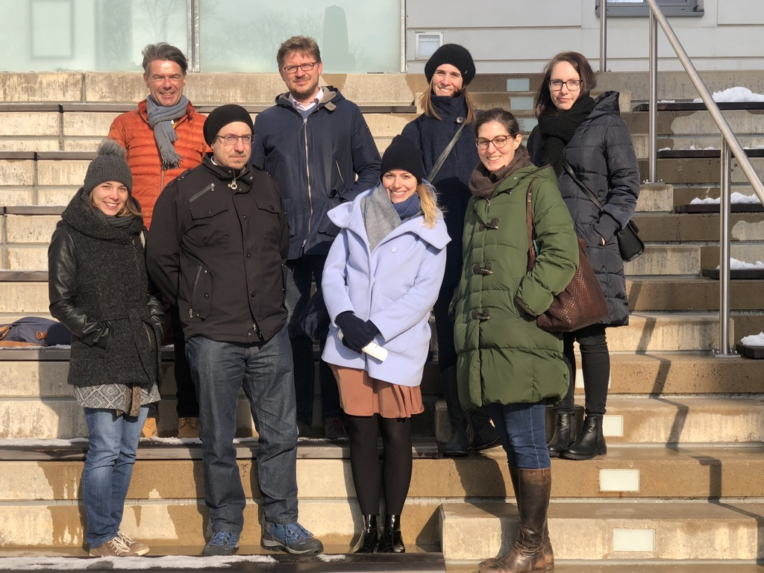
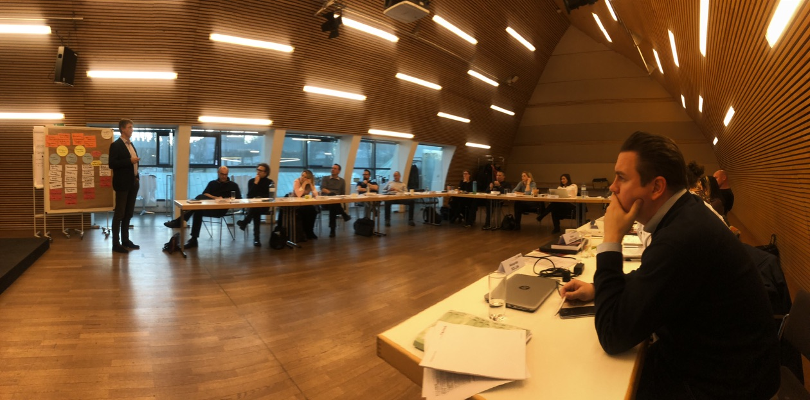

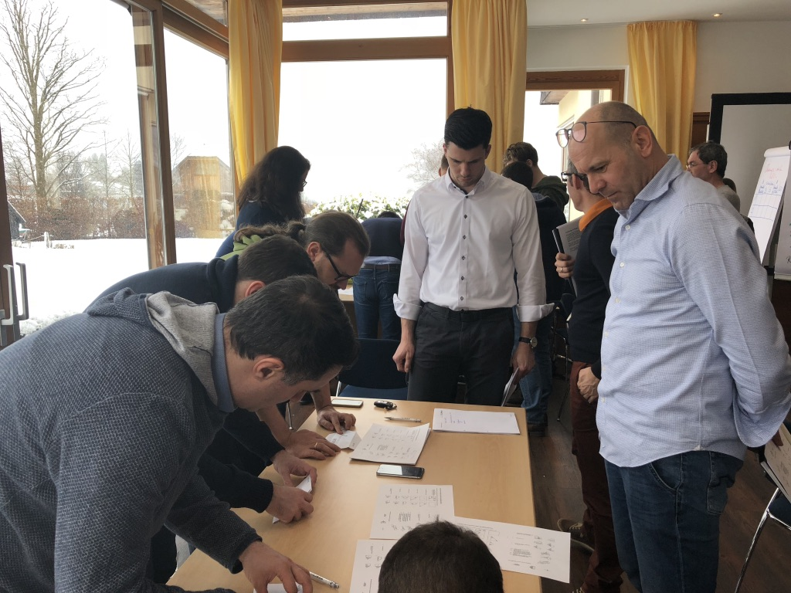
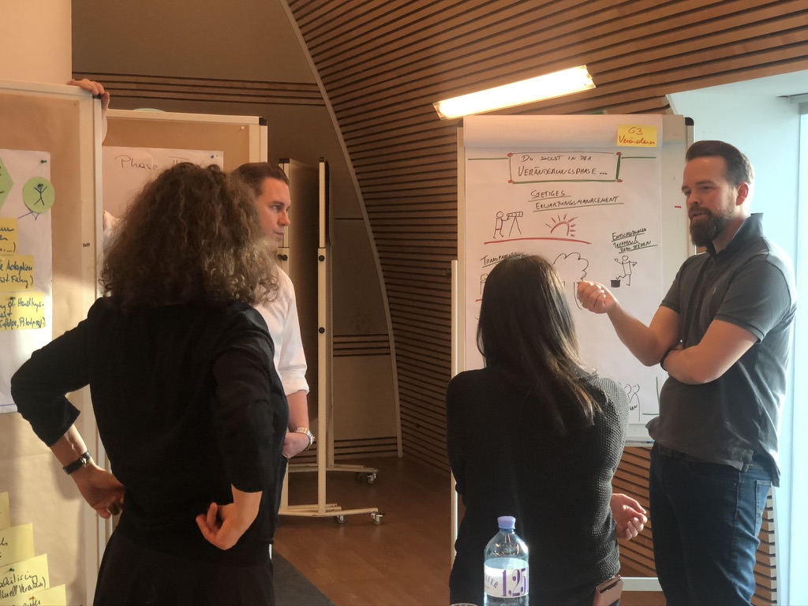
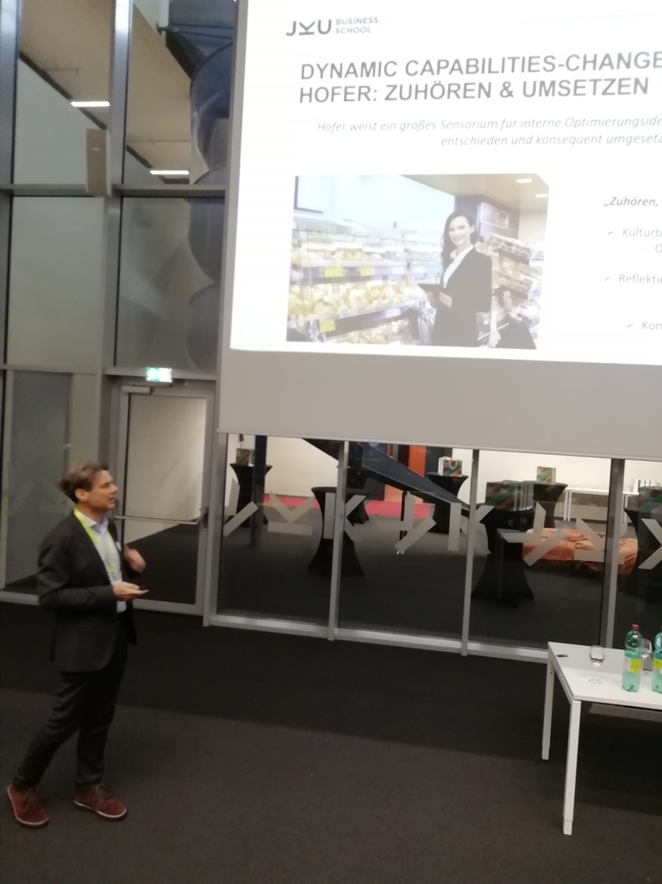
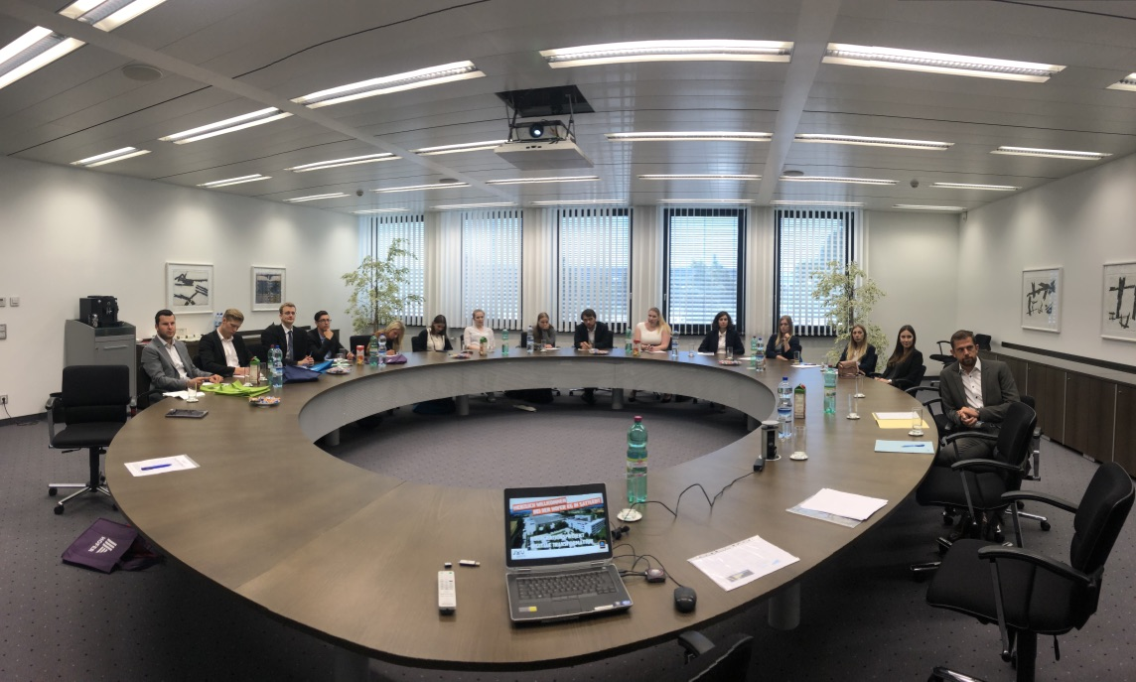
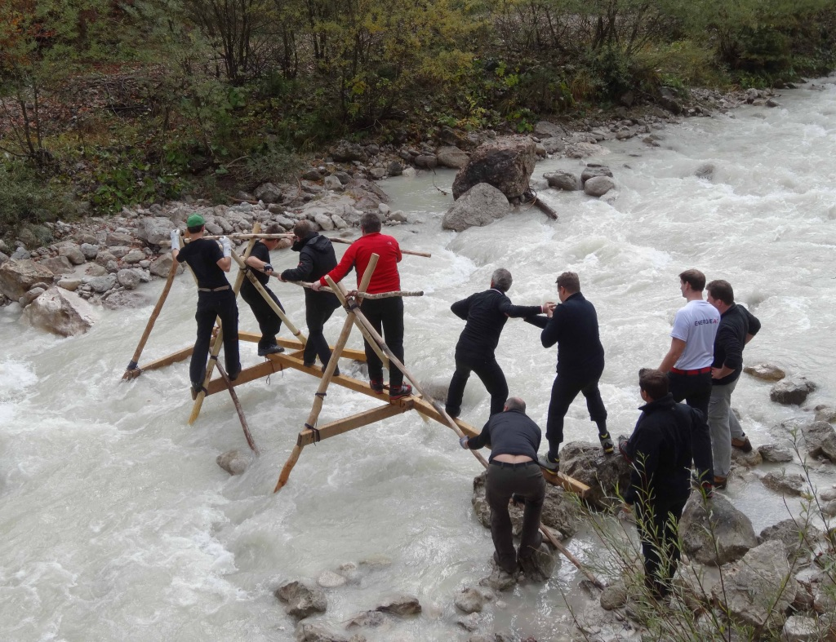
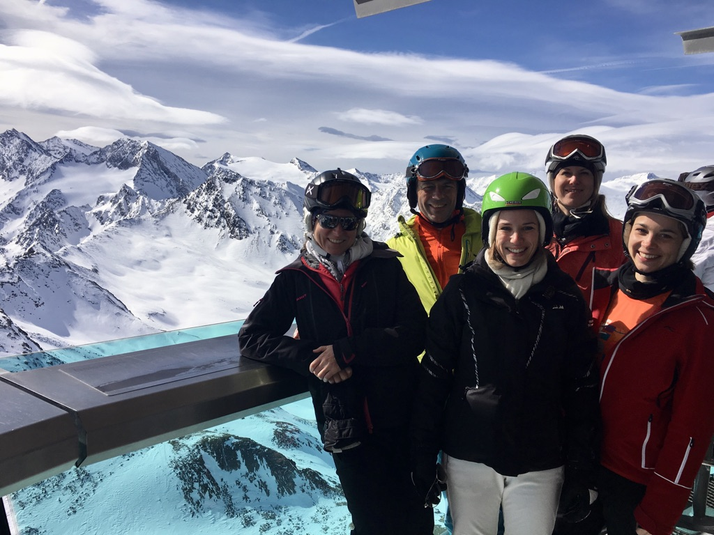
Change Lab Simulations
(LIMAK MBA)
Ski PhD-Seminars
(Obergurgl/JKU Linz)
Learning Journeys (ISTA/JKU Linz)
Case Studies (LIMAK MBA)
Guest Speakers (KTM Innovation/LIMAK)
Management Presentations
(Hofer KG/JKU Linz)
Practitioner Talks
(JKU Linz)
Group Dynamic Exercises
(LIMAK MBA)
Supervision of Habilitation & Doctoral Candidates

Habilitation
Barbara Müller (JKU Linz; Habilitation 2016)

Doctoral Candidates
- Stefan Konlechner (WU Vienna; Doctoral Thesis 2010)
- Daniela Weismeier-Summer (WU Vienna; Doctoral Thesis 2011)
- Bettina Baumgartner (JKU Linz; Doctoral Thesis 2011)
- Stefan Wilhelm (University of Liechtenstein; Doctoral Thesis 2012)
- Julia Trede (Hamburg University; Doctoral Thesis 2013)
- Christian Garaus (JKU Linz; Doctoral Thesis 2013)
- Wolfgang A. Marko (TU Graz; Doctoral Thesis 2014)
- Vera Roth (JKU Linz; Doctoral Thesis 2014)
- Ina Weinbauer (JKU Linz; Doctoral Thesis 2015)
- Karin Link (JKU Linz; Doctoral Thesis 2015)
- Nele Cannaerts (University of Antwerp; PhD Committee 2016)
- Irina Koprax (JKU Linz; Doctoral Thesis 2016)
- Hubert Lackner (JKU Linz; Doctoral Thesis 2017)
- Sylvia Schweiger (JKU Linz; Doctoral Thesis 2018)
- Georg Reischauer (TU Vienna; Doctoral Thesis 2018)

Other Theses
More than 300 Bachelor Theses, Master Theses, EMBA Theses, & Diploma Theses (between 1999 and 2020).

Management Positions & University Self-governance Services

Head of the Institute of Leadership & Change Management (JKU Linz: since 2009)
During the last 10 years I have restructured the institute to perform on an internationally visible level in research, to enable cutting-edge teaching, and to interact intensively with firms and managers in order to complete our “third mission”. Success is always a result of a well performing team and motivated team members. Nearly all of my team members were able to complete their PhDs (or Habilitation) at my institute. Most of them are (were) embedded sustainably in the academic community. The others moved to the consulting and training industry.

Dean & Managing Director (LIMAK Austrian Business School/JKU Linz: 2011 - 2015)
Together with my colleague in the executive team, I facilitated a large-scale organizational transformation of the Business School to overcome its crisis in 2010/2011. In 2011 and 2012, we developed a new strategy, completely new programs, new structures and processes etc. in order to return to a sustainable growth path. At the end of my tenure at the end of 2015, we achieved the best year to date in LIMAK’s history:
- Turnover: €1.5 million (2011) €3 million (2015); €4.5 million (2019): from massive losses to sustainable growth,
- Participants: 250 (2011) 1400 (2015); 1,500 (2019): growth in EMBA programs & in corporate programs,
- Programs: 2 (2011) 8 (2015); 10 (2019) and the development of a broad alliance concept.
Additionally, we increased the number of corporate management development-programs significantly. Austria’s top companies are now LIMAK’s customers: OMV, voestalpine, RLB Oberösterreich, Oberbank, MIBA, Greiner, OÖGKK, KGKK, SGKK, StGKK, AMAG, Vivatis, Engel, Miele, Pappas, AVE, Energie AG, Linz AG, Pöttinger, Teufelberger, CNH (FIAT), Siemens, Würth, KTM, Rosenbauer, Post AG, RLB Wien & Niederösterreich, Novomatic etc.

Dean of the Business School (JKU Linz: since 2019)
JKU Linz transformed the faculty into a business school in order to enhance the visibility, introduce innovative study programs, and to complete an accreditation process. In autumn 2019, my colleagues elected me as founding dean of this new institution. I currently act as a dean in addition to my responsibilities as the head of the Institute of Leadership & Change Management. In the meantime, we have launched new teaching programs, started the accreditation process, developed new research grants, and developed a strategy for the next decade.

Chairperson of the Association of the Business Administration Professors at JKU (JKU Linz: 2010-2011)

Chairperson & Member of the Study Commissions “Executive Education” (JKU Linz: since 2010)

Member of the Research & Teaching Fellowship Commission (JKU Linz: since 2010)

Chairperson & Member of 4 Appointment (Habilitation) Committees & 6 Selection Committees (JKU Linz: since 2010)

Dean (UNIKIMS Kassel International Management School/Kassel University: 2009)

Transfer & Third Mission: Management Development & Consulting

Management Science as an applied academic discipline requires efforts for completing the universities’ third mission. Consulting & management development serve as a means for transferring cutting-edge knowledge from research to specific business practice. However, such projects often also pave the way for getting access to interesting case studies and other insights into leadership & organizational challenges. Furthermore, consulting and management development creates an opportunity for learning from leaders and organizations in order to readjust research efforts or to enrich (executive) teaching with insights from established practice. Interacting with firms and practitioners requires trust, expertise, and sometimes specific approaches for establishing a sustainable working relationship. We have, therefore, developed specific approaches at the institute, labeled as Scientific Consulting (SciCon) and Scientific Investigation (SciIn) for managing expectations during the cooperation (published in the Austrian Management Review 2019). While Scientific Investigation provides methods for primarily conducting an organizational analysis, Scientific Consulting additionally includes methods and social settings for solving practical business challenges together with clients.

Management Development - Executive Education

Executive education serves as an excellent opportunity for joint learning processes between academia and practitioners. My topics in management development-programs range from leadership, group dynamics and team development, organizational design & culture, strategic management, to strategic & organizational change; always perceived from a leadership perspective. I stimulate reflection and the refinement of the leader’s decision-making skills by combining theoretical explanations with group dynamics exercises, case studies (also from participants), guest talks, learning journeys, and discussions. During the last decade, I have spent several days in management development-trainings each year. My main clients are LIMAK’s EMBA programs, Rosenbauer, KTM, Oberbank, RLB Niederösterreich & Wien, Post AG, Oberbank, voestalpine, Land Salzburg, Verwaltungsakademie der Republik Österreich and Swietelsky among others. Additionally, I also give some courses on change management at the CUOA Business School (University of Padua) in the Innovation Management & in the International EMBA programs. I frequently use my book “Erfolgreich in trubulenten Zeiten: Impulse für Leadership, Change Management und Ambidexterity“ as well as the transfer journal “Austrian Management Review” as core literature for executive education.

Consulting - Action Research

Owing to my consulting background, transfer activities also include consulting projects, which often follow the Scientific Consulting-approach. I started my consulting career as a full-time consultant at Daimler-Benz AG in Stuttgart (Germany) in 1997 and continued at Diebold (Daimler-Chrysler AG) in Vienna (Austria). At the end of 1999, I returned to the academic world and I acted as an independent Management Consultant by founding my own consultancy Güttel Management Consulting, Research, & Training. My main topics range from team development, organizational development (including management development, evaluations, & best-practice transfer) to strategic transformation. Current topics such as digital transformation are addressed by my research field of ambidexterity. Thus, I frequently combine consulting with action research or other applied research activities. Well-known companies have worked with me during the last few years: e.g. Boehringer-Ingelheim, Würth, FACC, OMV, voestalpine, Hofer, Lenzing, Münze Austria, Pöttinger, OÖGKK, KGKK, gespag/Oberösterreichische Gesundheitsholding, Austrian Institute of Technology and Technosert among others.

Media Activities

Frequent media activities are necessary to ensure that research results are disseminated to the business community. Therefore, I cultivate and foster my television, broadcasting companies and newspaper network in order to facilitate translating cutting-edge knowledge for the business practice.

