International Symposium on Impact Engineering 2019; 2nd – 5th July, Gmunden Austria
International Symposium on Impact Engineering 2019
Graphical Abstract

Title of your paper (Title Paper, Arial 14, Bold)

FULL First Author^{1, a *}, FULL Second Author^{2,b}, and FULL Last Author^{3,c} (Authors, Arial 14)

¹Full address of first author, including country

²Full address of second author, including country

³List all distinct addresses in the same way

ªemail, ^{b}email, ^{c}email

* please mark the corresponding author with an asterisk (Affiliation, Arial 11)
Keywords: List the keywords covered in your paper. These keywords will also be used by the publisher to produce a keyword index.

Content instructions
The submitted abstract should contain 400 – 600 words and two images aimed at raising the curiosity of the participants regarding the work that is to be presented in the keynote lecture. The abstract should fit within 2 pages.

Subtitle 1
Please use the style Subtitle 1 to mark the beginning of a new section (Arial 12 Bold, spacing: before 18 pt, after 6pt).
Tables. Tables (refer with: Table 1, Table 2, ...) should be presented as part of the text, but in such a way as to avoid confusion with the text. A descriptive title should be placed above each table. Units in tables should be given in square brackets [meV]. If square brackets are not available, use curly {meV} or standard brackets (meV).
Language. All text, figures and tables must be in English.
Figures. Figures (refer with: Fig. 1, Fig. 2, ...) also should be presented as part of the text, leaving enough space so that the caption will not be confused with the text. The caption should be self-contained and placed below or beside the figure. Generally, only original drawings or photographic reproductions are acceptable. Only very good photocopies are acceptable. Utmost care must be taken to insert the figures in correct alignment with the text. Half-tone pictures should be in the form of glossy prints. If possible, please include your figures as graphic images in the electronic version. For best quality the pictures should have a resolution of 300 dpi(dots per inch).
Equations. Equations (refer with: Eq. 1, Eq. 2, ...) should be indented 5 mm (0.2"). There should be one line of space above the equation and one line of space below it before the text continues. The equations have to be numbered sequentially, and the number put in parentheses at the right-hand edge of the text. Equations should be punctuated as if they were an ordinary part of the text. Punctuation appears after the equation but before the equation number.
c² = a² + b². (1)

Literature References
References are cited in the text just by square brackets [1]. (If square brackets are not available, slashes may be used instead, e.g. /2/.) Two or more references at a time may be put in one set of brackets [3,4]. The references are to be numbered in the order in which they are cited in the text and are to be listed at the end of the contribution under a heading References, see our example below.
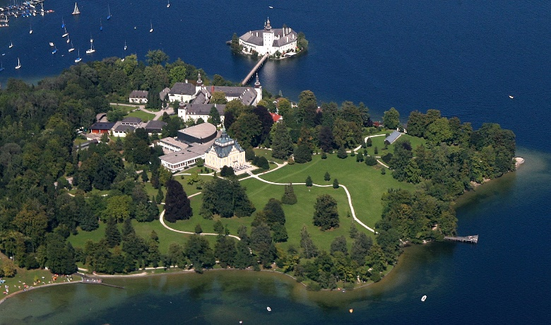
Figure 1 - Villa Toscana, conference venue
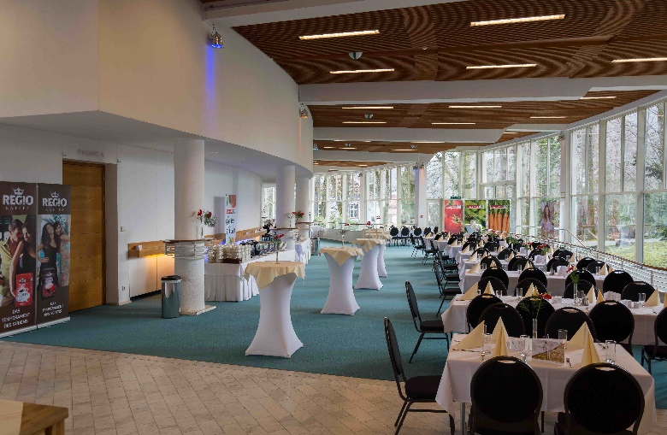
Figure 2 - Conference venue, inside view

References
[1] J. van der Geer, J.A.J. Hanraads, R.A. Lupton, The art of writing a scientific article, J. Sci. Commun. 163 (2000) 51-59.
Reference to a book:
[2] W. Strunk Jr., E.B. White, The Elements of Style, third ed., Macmillan, New York, 1979.
Reference to a chapter in an edited book:
[3] G.R. Mettam, L.B. Adams, How to prepare an electronic version of your article, in: B.S. Jones, R.Z. Smith (Eds.), Introduction to the Electronic Age, E-Publishing Inc., New York, 1999, pp. 281-304.
[4] R.J. Ong, J.T. Dawley and P.G. Clem: submitted to Journal of Materials Research (2003)
[5] P.G. Clem, M. Rodriguez, J.A. Voigt and C.S. Ashley, U.S. Patent 6,231,666. (2001)
[6] Information on http://www.weld.labs.gov.cn

