RESERVATION OF ACCOMMODATION AT USB UNIVERSITY DORMITORIES
Instructions for students of biological chemistry – 2nd year

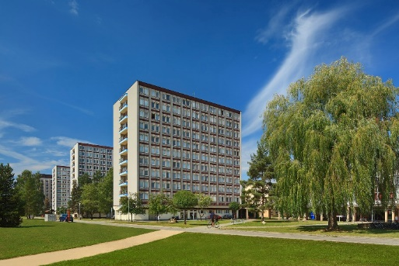
1st step: Request for accommodation (by 15th June)
You can request for an accommodation at USB dormitories through the online form.
It is not possible to choose in which residence or room you will stay, the place will be assigned to you according to current room availability.
Description of dormitories available here: http://www.jcu.cz/study-at-usb/practical-info/accommodation/university-dormitories

2nd step: Confirm the reservation by paying the reservation fee (by 31st July)
In the beginning of July you will receive information in which dormitory you will be assigned.
In order to confirm your reservation, it is necessary to pay a reservation fee of 2000 CZK (about 80 EUR).
On the start day of your accommodation at USB dormitories, this amount of 2000 CZK will be kept as an accommodation deposit until the date of your departure for covering eventual damage or cleaning. It will be refunded at the condition that no damage was found.

You have to send the fee of 2000 CZK by 31st July to the following bank account:
BIC: CEKOCZPP
IBAN: CZ35 0300 0000 0001 6949 2602
Reference for payment: your personal student number
Name of the beneficiary of the account: Jihoceska univerzita v Ceskych Budejovicich
Czech Bank name: ČSOB
It is very important to indicate your personal student number to identify the payment. You can indicate it into the „Reference for payment“ or “message for payee”.

If you decide to cancel your reservation, you should do it by the 31st July. If you don´t pay the reservation fee, the reservation will be automatically cancelled.
Please, inform us if you plan to arrive at a different date that the one you previously indicated.

The reservation fee is non-refundable.

3rd step: Accommodate at the dormitory
You have to get accommodated at the latest on 30th September 2020.
If you don´t show up by the beginning of the semester, the reservation fee will not be paid back.

On the day of arrival, you will have to pay the two first monthly rents in advance in cash or by card.
Also remember that there is a 30 days notice period for cancelling the accommodation contract prematurely.
In any case, it is very important to read carefully the Student Accommodation code and respect the rules indicated.

