Manuscript preparation guidelines for protocols for the Electrochemistry lab course

Protocol
(max. 4 pages including title page!)

Prepared in winter/summer semester 20xx

Electrochemistry lab course

Last name First name
kxxxxxxxx, 000

Introduction (14 pt bold)
This part is written using Times New Roman 10 pt and it should describe the topic of your report and a short overview of which experiments were carried out and analytic devices were used.
The entire paper should be formatted using justify alignment and with 1.5 Space. Between chapters leave an empty line with 1 Space. There is no minimum number of pages required, but the amount of information given should be detailed enough to present clearly the topic. You can use this template to write your report or format the report using:
- Margins: Top: 3.5 cm, Bottom: 3 cm, Inside: 1.5 cm and Outside: 1.5 cm.
- Orientation: Portrait
- Pages: Mirror margins
- Paragraphs: Indentation: Left: 0 cm, Right: 0 cm Special: First line: 0.55 cm. Spacing: Before: 3 pt, After: 3 pt
- No page numbers are required
The entire paper should be written using academic (impersonal) voice. Do not use “I believe…”, “In my opinion…”, “…you can see”.
Int the report you should also include cited literature (the references). The references should be cited between brackets [] and they should appear in order. If the references are at the end of the sentence place them before the point [1]. If you want to cite more than one reference do it in the following way: [1-4] for references 1, 2, 3, 4 and [1, 6, 9] for references 1, 6 and 9. For a combination of both types, use: [1-4, 6, 9] for references 1, 2, 3, 4, 6, 9.
Details about how to format the references and what should be included can be seen at the end of this paper. Be sure to cite and NOT to plagiarize!!!

Experimental (14 pt bold)
  - Subchapter (if needed) (12 pt bold) In this section you should describe in detail the experimental part of your technological work. You should describe what equipments / setups you used / built for your work, and what experimental conditions you used. Here it is desired to show a photograph and / or schematic drawing of your experimental setup.

Equations should be numbered sequentially and they should appear on a separate line, centered:
$$E=mc^{2}$$ | (1)
where: E = energy
m = mass
c = speed of light
Each physical dimension and abbreviation must be explained upon first use (see above).

Results and discussion (14 pt bold)

In this section you should present your experimental results, and try to explain and interpret them (using references if necessary). If some problems occurred while doing the experiments, explain these problems and justify why you did not obtain the aimed results. Suggest some solutions for improving the experiment.

In this part you should include also most of the Figures and Tables (if necessary to express better your research). Figures and Tables should be numbered in order (Figure 1 / Table 1, Figure 2 / Table 2,…). Captions should be placed below the Figure and on top of the Table, respectively and they should be written using Times New Roman 9 pt. Only “Figure / Table” and the figure / table number should be written in bold. The caption for both tables and figures should clearly and adequately describe the table or figure, respectively.

When you make a graph, follow these rules. The font used is Times New Roman. The axis labels are 36 pt, and the numerical values on the axis are 28 pt. Apply for the axis the following conditions: Thickness: 2, Major and Minor ticks: IN. If you need to write some text in the graph, use large enough fonts (> 20 pt).

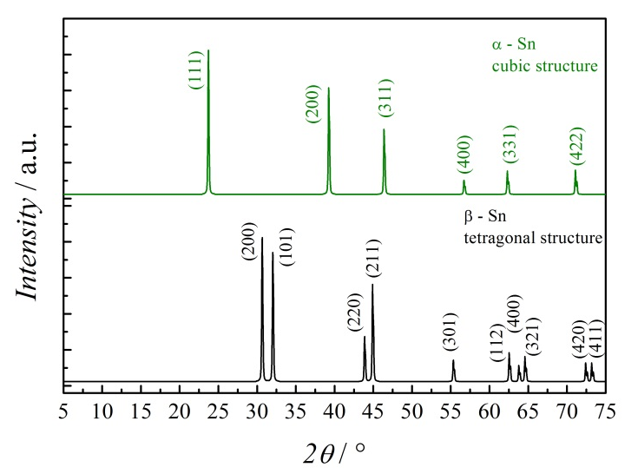
Figure 1 X-ray diffractograms of α-Sn and β-Sn polycrystalline sample showing the different crystal structures. The crystallite orientations are indicated by Miller indices [10]. If the Figure was taken from a reference, cite the reference in the caption.

Axis labels are indicated as following: physical dimension / unit (e.g. T / K or σ / MPa). Units should be separated as following: MPa s⁻¹. Numerical values and units are separated by spacing; mA and m A represent different units! Symbols and units must be used in a consistent manner in the entire paper. The number format should not use comma, but the decimal point.

It is preferable to use both in the text and the figures scientific notation as in 3.5 × 10^{–4} A, or 0.35 mA (no engineering notation like 3.5 E^{–4}). Units (e.g. A cm⁻¹, K, Ω) should be written in upright letters (not in italics). SI units must be used. Between the number and the unit, as well as between individual units (A cm⁻¹) use the unbreakable space created by the combination of Ctrl+Shift+Space keys. Like this, at the end of the line the number and the unit are bound together (not the number at the end of the line and unit at the beginning of the following line).

In the Tables, the font should be Times New Roman 9 pt. The text inside the Table should be aligned to the left, if necessary right (like in the last column from Table 1).
Table 1 Fonts and font sizes used for this paper
Style | Font | Size / pt
Title | Times New Roman | 28
Author | Times New Roman bold italic | 20
Main text | Times New Roman | 10
Heading | Times New Roman bold | 14
Inline heading | Times New Roman bold | 12
Figure caption | Times New Roman | 9
Table title | Times New Roman | 10
Table body | Times New Roman | 9
Equations | Times New Roman | 10
References | Times New Roman | 9

Conclusions (12 pt bold)

In this section you should make a short summary of the information presented in the paper and draw some conclusions.

References (10 pt bold)

All authors should be cited. References that contain et al. are not allowed with the exception of extreme cases with > 20 authors. The journal abbreviated name can be found on CASSI website: http://cassi.cas.org/search.jsp

The scientific articles should be cited as:

[1] F. First author family name, S. Second author family name, and L. Last author family name, “Title of the article”, Journal abbreviated name Volume (year) first page-last page

[2] A. W. Hassel, and D. Diesing, “Breakdown of ultrathin anodic valve metal oxide films in metal-insulator-metal-contacts compared with metal-insulator-electrolyte contacts”, Thin Solid Films 414 (2002) 296-303

[3] F. First author name, S. Second author name, and L. Last author name, Title of the Book (Publisher, City, year), first page-last page

[4] F. First editor name, S. Second editor name, and L. Last editor name (eds.), Title of the Edited Book (Wiley-VCH, Berlin, 2000), first page-last page

[5] F. Contributor author name, Title of the Contribution, Followed by the Title of the Series of Books, Vol. 1 (Publisher, City, year), chap. 1

